HAPPY NEW YEAR!
Welcome to 2012! We hope lots of GREAT reading is in store for you this year! If you got an e-reader over the holidays, remember you can download e-books from us. See our website: www.beagle-books.com

Night-In
Tell your friends! Tell your neighbors! Tell complete strangers! Tell family members that you like! Once again, Sally and Jen are planning a night in at Beagle Books – a night filled with chocolate, wine, cheese, cider, book talks, and prizes! If you belong to a book group (any book group) or WANT to be part of a book group, please join us! Men and women welcome. We’ll hold the Night-In on Saturday, January 21st at 7PM.
Midwest Connections Picks  January Pick:
The Magic Room: A Story About the Love We Wish for Our Daughters by Jeffrey Zaslow $27 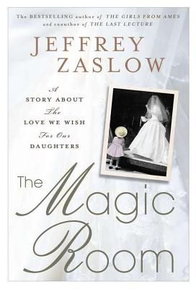 You may not have heard of Fowler, Michigan, much less Becker's Bridal. But for the thousands of women who have stepped inside, Becker's is the site of some of the most important moments of their lives-moments that speak to us all. Housed in a former bank, the boutique owners transformed the vault into a "magic room," with soft church lighting, a circular

pedestal, and mirrors that make lifelong dreams
come true.
Illuminating the poignant aspects of a woman's journey to the altar, The Magic Room tells the stories of memorable women on the brink of commitment. Run by the same family for years, Becker's has witnessed transformations in how America views the institution of marriage; some of the shop's clientele are becoming stepmothers, or starting married life for a second time. In The Magic Room, Zaslow turns his perceptive eye to weddings and weaves together secrets, memories and family tales to explore the hopes and dreams we have for our daughters.
We missed one in December – oops! So here it is: Little Dickens: A Droll and Most Extraordinary History. Written by Tom Hegg. Illustrated by Kevin Cannon $19.95 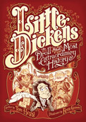 Tom Hegg takes several Dickens characters from different novels, mixes them together with newly-minted ones, puts them all in Mortal Danger, and sets the story to wickedly clever verse.
Staff Picks
Jamie: American Boy by Larry Watson 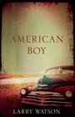

Gail:
A Name of Her Own by Jane Kirkpatrick 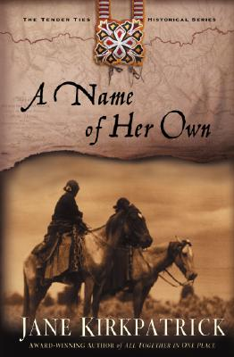 Gail says: This is a fiction story based on the second expedition to the Pacific Ocean after Lewis and Clark.
Fortunate Four & other Journeys of the Heart by Joy Kuby
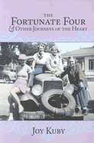 Twenty Chickens for a Saddle by Robyn Scott 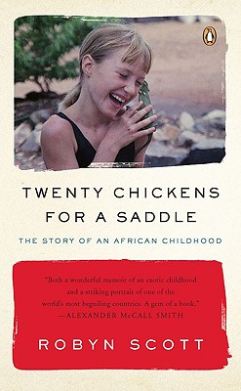 Gail says: A memoir of growing up in Botswana. Reminiscent of Lets Don't Go to the Dogs Tonight. I think I liked this one even better.
A Week in Winter by Marcia Willet 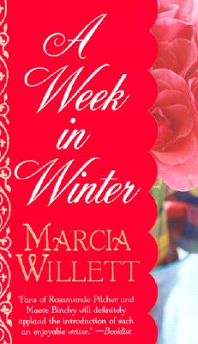 The Mapping of Love and Death by Jacqueline Winspear 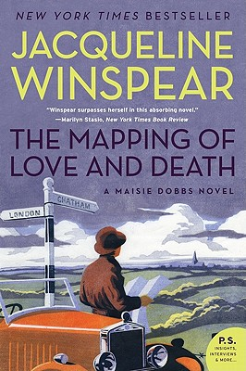 Gail says: This is part of a series. The

protagonist is a woman detective in England right after World War I. The book gives lots of historical facts plus a good mystery!

Linda: V is for Vengeance by Sue Grafton 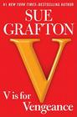 Linda says: Grafton is at the top of her game with the latest misadventures of private investigator Kinsey Millhone. I've eagerly read every one of the Grafton mysteries, starting with A is for Alibi, and they just keep getting better.

Kathy:
I Remember Nothing by Nora Ephron
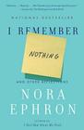

Sally: The Soldier's Wife by Margaret Leroy 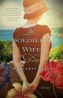 Sally says: I've been wanting to read this book ever since it came out last summer, and am enjoying it a great deal. The other books I'm reading are for the Night-In, and I'm not telling what they are until Jan 21! Please join us for this great evening for book club members.

DON’T FORGET NIGHT-IN IS SATURDAY, JANUARY 21ST AT 7PM AT BEAGLE BOOKS & BINDERY!

Jen:
Game of Thrones: A Song of Ice and Fire: Book One by George R.R. Martin 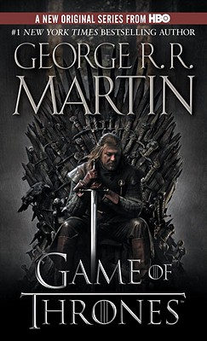 Jen says: I am making myself read this slowly with frequent references to the appendix in the back of the book. I’m also reading a number of other books which I refuse to disclose until Night-In ☺

Jody:
The Girl Who Could Fly by Victoria Forester 
Glimpses of Heaven: True Stories of Hope and Peace at the End of Life’s Journey by Trudy Harris
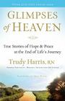

DON’T FORGET NIGHT-IN IS SATURDAY, JANUARY 21ST AT 7PM AT BEAGLE BOOKS & BINDERY!

Youth Yak
Hannah’s back! Hannah’s back! (Our voracious YA reader!!) Here’s what she’s reading!:
At the moment:
Girl Meets Boy - edited by Kelly Milner Halls 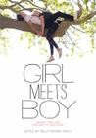
Cold Kiss by Amy Gavey
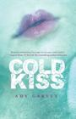
For the month:
The Statistical Probability of Love at First Sight by Jennifer E. Smith
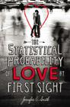
Bloodrose by Andrea Cremer
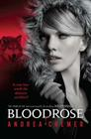
Under the Never Sky by Veronica Rossi
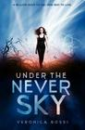

Past Perfect by Leila Sales

Don't Expect Magic by Kathy McCullough
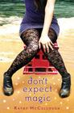

For more up-to-date info on Hannah’s reads, check out her blog on our website!
http://www.beagle-books.com/

Book Group Reads
Beagle Books Mens Book Group
Tuesday, January 17th at 8AM:
How We Decide by Jonah Lehrer $14.95
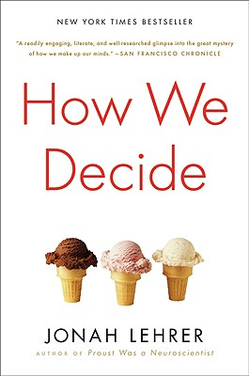

Beagle Books Womens Book Group
Wednesday, January 12th at 6PM:
The Bird Sisters by Rebecca Rasmussen $14
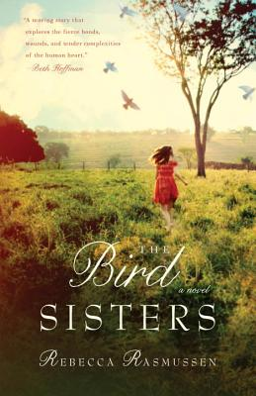

Kindle Fire
Did some silly person in your family get you a Kindle Fire e-reader from Amazon for the holidays and now you’re suffering from “But I want to support my local indie bookstore” syndrome? Fear not, you can download from us! See http://www.beagle-books.com/files/sisterwolfbooks/KindleFire.png for details!

DON’T FORGET NIGHT-IN IS SATURDAY, JANUARY 21st AT 7PM AT BEAGLE BOOKS & BINDERY! SEE YOU THEN!!

