Minnesota Book Award Short Lists Announced
The Short Lists for the Minnesota Book Awards have been released! Many of these titles should be familiar to you as Midwest Connections Picks and/or selections from our MBA catalog! Just for fun, email Jen your guess as to how many there are (both Midwest Connections Picks and catalog) in the lists: beagle-books@arvig.net The first three people to send in correct entries will get a $5 gift certificate! And the titles are…………:
Children's Literature 1+1=5 and Other Unlikely Additions by David LaRochelle, illustrated by Brenda Sexton 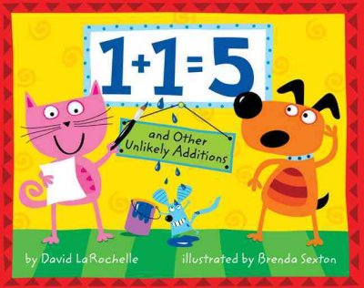 *one of Jen’s favorites! Emma's Poem: The Voice of the Statue of Liberty by Linda Glaser, paintings by Claire A. Nivola 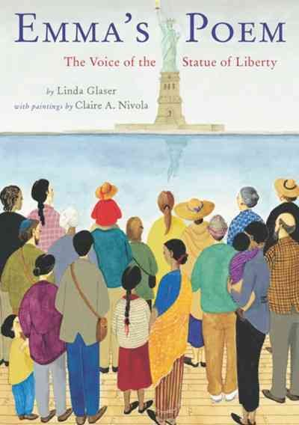 My Heart Is Like a Zoo by Michael Hall 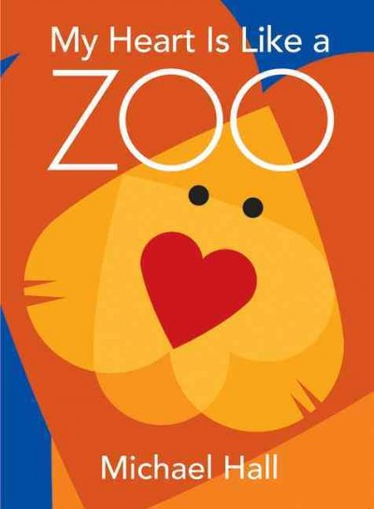 A Night on the Range by Aaron Frisch, illustrated by Chris Sheban 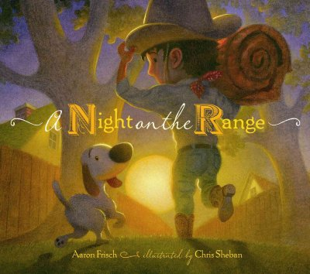

General Nonfiction The Assassination of Hole in the Day by Anton Treuer 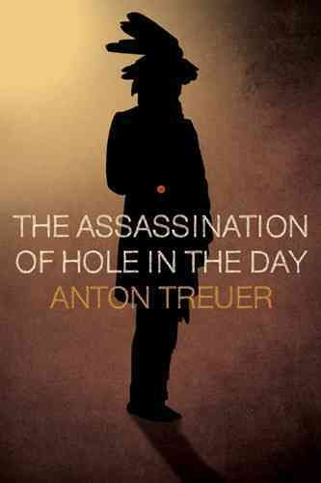 *A Night-in Pick! The Nature of College: How a New Understanding of Campus Life Can Change the World by James J. Farrell  The Opposite of Cold: The Northwoods Finnish Sauna Tradition by Michael Nordskog and Aaron W. Hautala  Paddle North: Canoeing the Boundary Waters-Quetico Wilderness by Greg Breining and Layne Kennedy 

Genre Fiction Silencing Sam by Julie Kramer 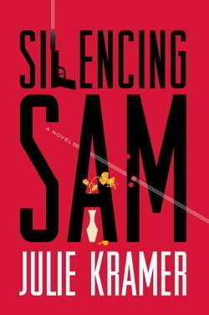 *Beagle Books 2010 Pie Judge! The Taking of Libbie, S.D. by David Housewright 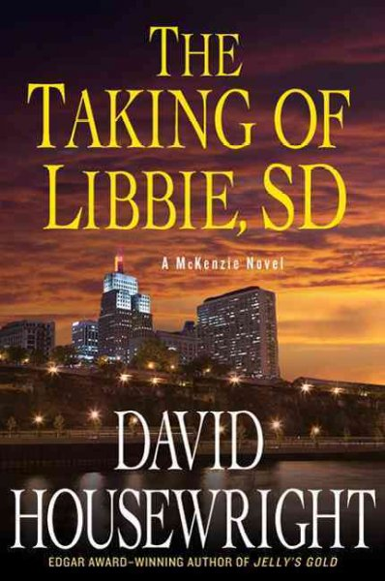 The Tale of Halcyon Crane by Wendy Webb 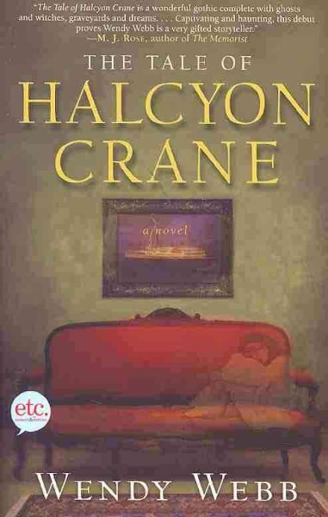 Vermilion Drift by William Kent Krueger 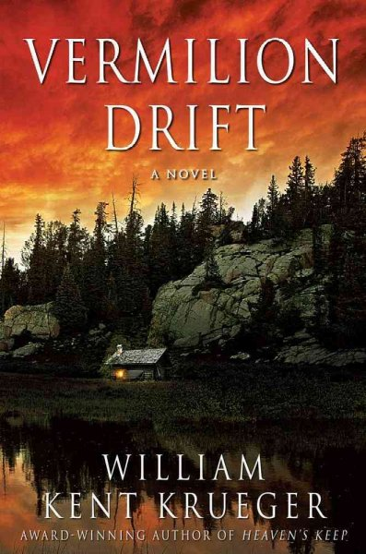 *Festival Author at Sister Wolf 2010!
Memoir & Creative Nonfiction Carrier: Untangling the Danger in My DNA by Bonnie J. Rough 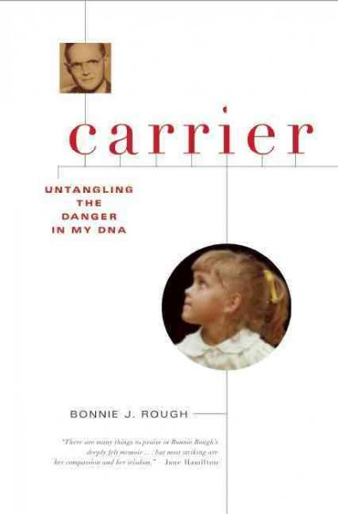

Crossing the Barriers: The Autobiography of Allan H. Spear by Allan H. Spear  News to Me: Adventures of an Accidental Journalist by Laurie Hertzel 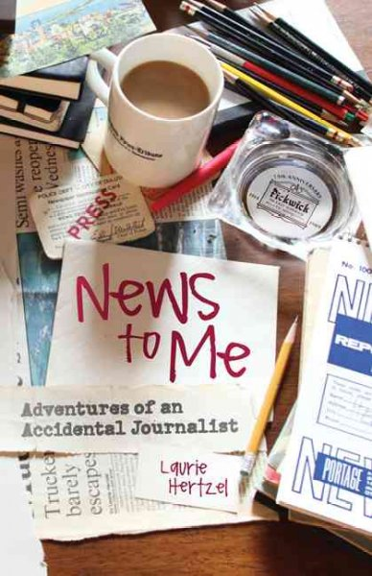 *A Night-in Pick! She Looks Just Like You: A Memoir of (Nonbiological Lesbian) Motherhood by Amie Klempnauer Miller 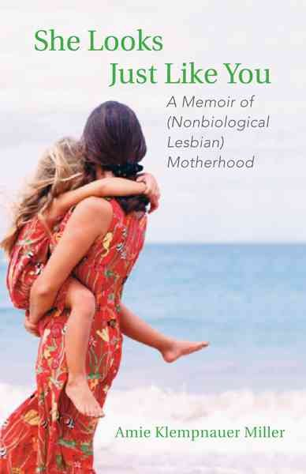
Minnesota North Country: The Making of Minnesota by Mary Lethert Wingerd 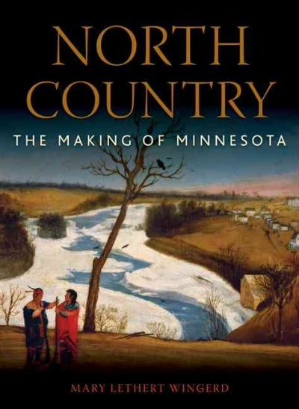 *Festival Author at Sister Wolf 2010! Prairie, Lake, Forest: Minnesota's State Parks by Chris Niskanen and Doug Ohman 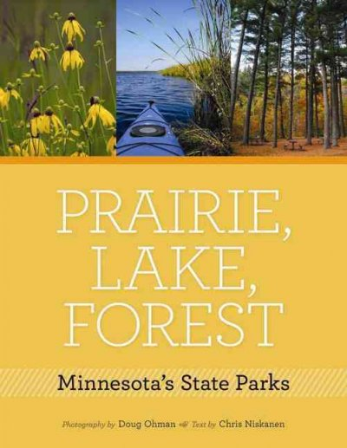

This Is Not Florida: How Al Franken Won the Minnesota Senate Recount by Jay Weiner  We're Gonna Win, Twins!: 50 Years of Minnesota's Hometown Team by Doug Grow 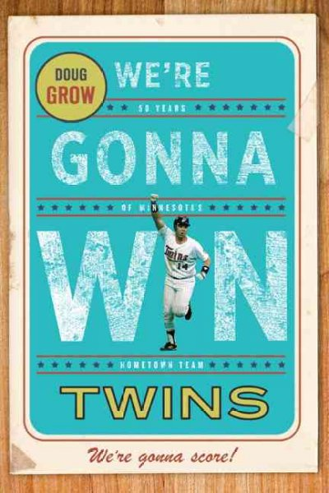
Novel & Short Story Dogfight, A Love Story by Matt Burgess 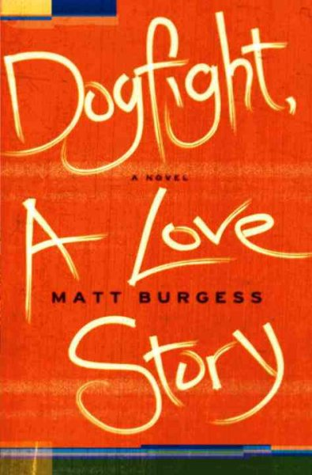 The House of Tomorrow by Peter Bognanni 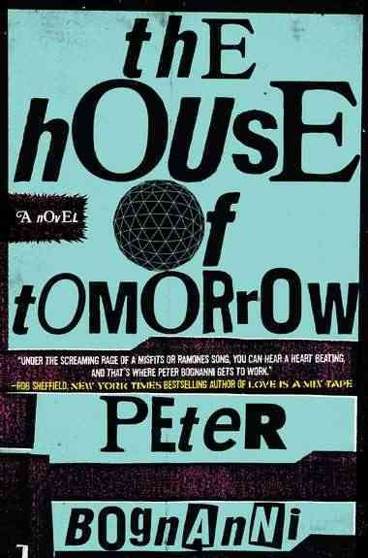 *A Night-in Pick! Losing Camille by Paul Kilgore 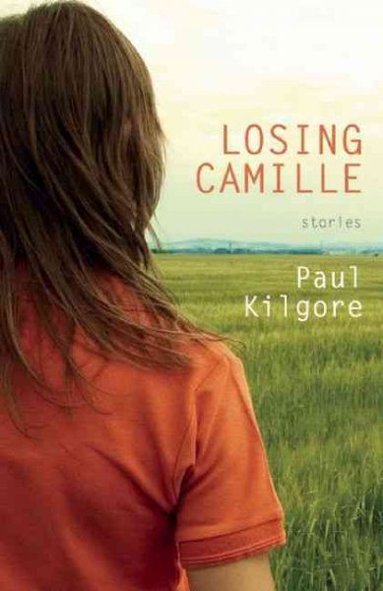

Vestments by John Reimringer  *A Night-in Pick!
Poetry Dreaming Man, Face Down by Mark Conway 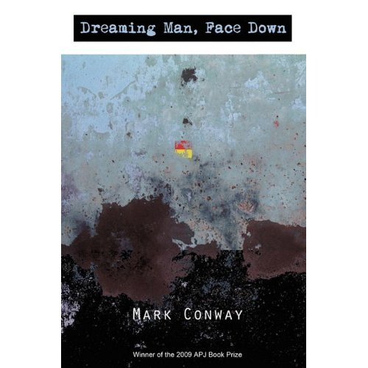 Find the Girl by Lightsey Darst  On Speaking Terms by Connie Wanek 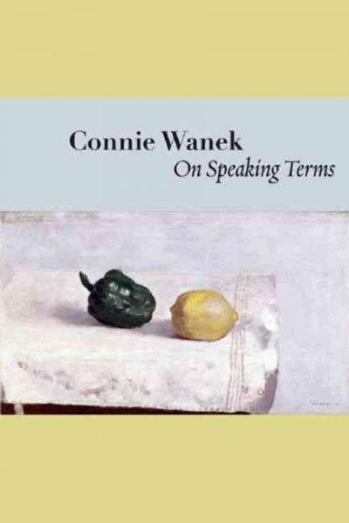 Sin Eater by William Reichard 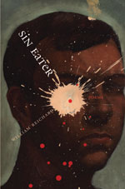

Young People's Literature Blank Confession by Pete Hautman 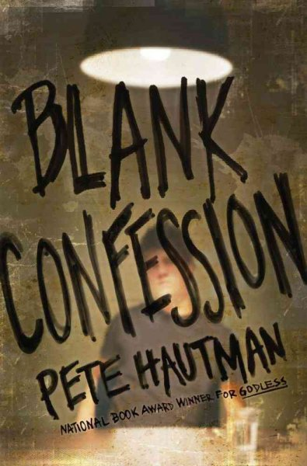 Hamster Magic," by Lynne Jonell 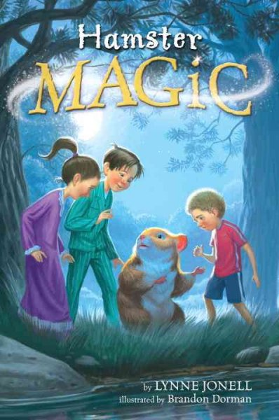 The Shadows: The Books of Elsewhere; Volume I by Jacqueline West 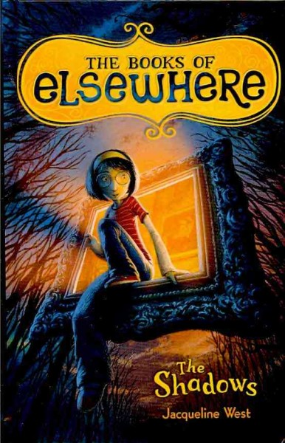 *Beagle has signed copies! Split by Swati Avasthi 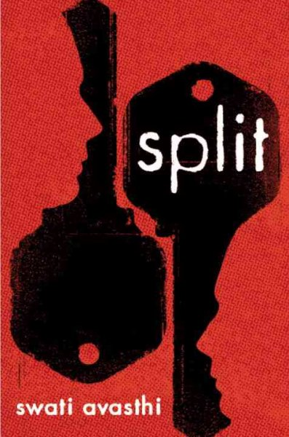
Winners will be announced April 16 at the Crowne Plaza Hotel in downtown St. Paul.
All Minnesotans are invited to vote for the Readers' Choice Award during the month of March at TwinCities.com (Don’t worry, we’ll remind you ☺)

Midwest Connections Picks  February Picks: Mercy Kill by Lori Armstrong $15 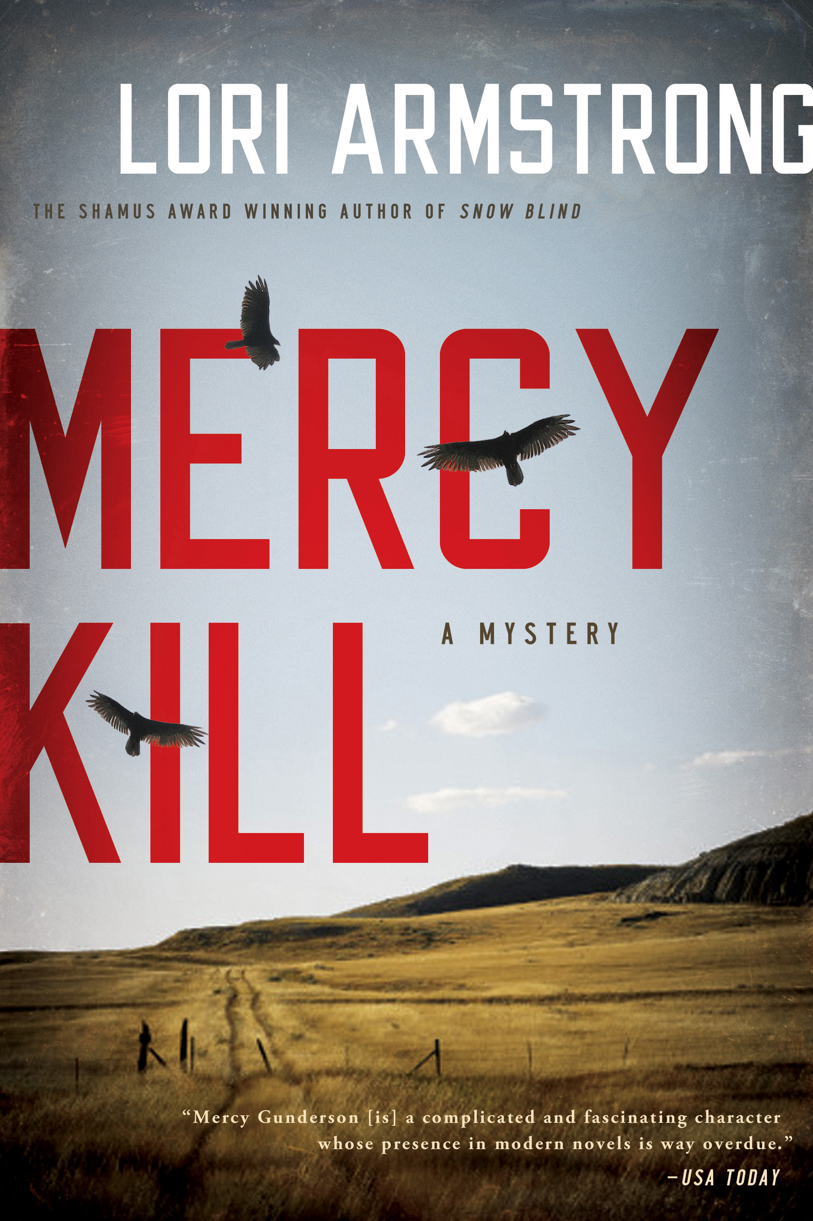 Former Black Ops army sniper Mercy Gunderson isn't adjusting well to the laid-back rhythm of civilian life on her family's ranch in South Dakota. To fill her time, Mercy accepts a temporary bartending gig at a local watering hole. Yet her attempts to settle in back home are tested when Titan Oil, a Canadian company proposing to run an underground pipeline through Eagle River County, sends Jason Hawley, Mercy's former army buddy, to the area to convince ranchers to get behind the project.
While local business owners support the pipeline, Hawley's presence riles the landowners, and Mercy is torn. After ugly threats and multiple altercations escalate tensions in the county, Mercy discovers Hawley's brutally mutilated body in the bar parking lot. When it appears Sheriff Dawson cares more about campaigning for reelection than investigating the case, Mercy vows to find Jason Hawley's killer—even if she has to run against Dawson for sheriff to ensure justice is served.
But Mercy soon learns her former military pal had plenty of secrets. Her search for the truth brings unwanted exposure to the county's dark side and risks deadly repercussions for the entire community.

Pioneer Woman: Black Heels to Tractor Wheels--A Love Story by Ree Drummond $25.99 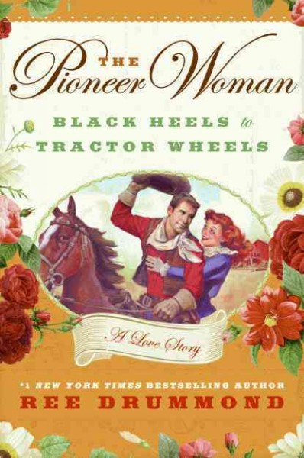 Can a city girl trade in her love of shopping and sushi to live on a cattle ranch in the isolated plains of Oklahoma? If it’s Ree Drummond, the answer is a whole-hearted yes. When she unexpectedly fell for a hard-working cattle rancher she calls Marlboro Man, Drummond launched the wildly popular blog Pioneer Woman.
In her charming new memoir, Ree tells the story of her whirlwind romance and reminds readers of what’s really important: family, hard work, simplicity, and the love of a chaps-wearing cowboy.
Staff Picks Before we get started with the Staff Picks, we need to introduce you to the newest staff member……..EMILY! Emily graduated from Park Rapids High School in 2010 and LOVES to read. She has also been heavily involved in theater. You may have seen her in a production at Long Lake Theater! Emily is training in at Beagle Books this winter and then plans to work at Sister Wolf Books this summer. We’re so glad to have her on staff. Be sure to greet her when you see her behind the counter! So……here’s what Emily is currently reading: Linger by Maggie Stiefvater $17.99 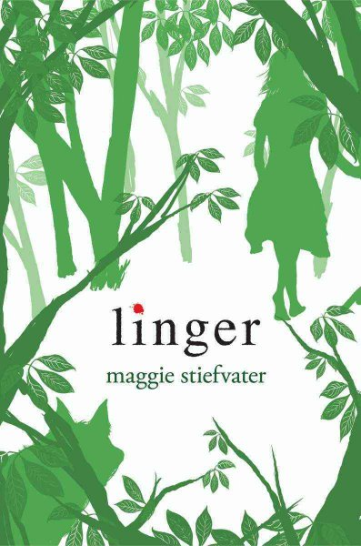

Harry Potter and the Deathly Hallows by J.K. Rowling $14.99 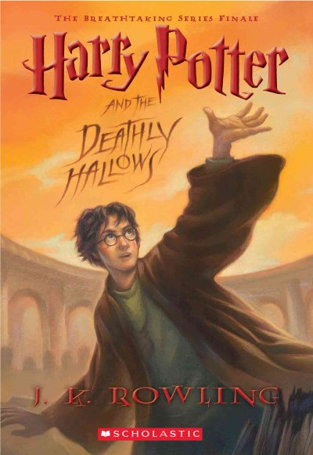
Chronicles of Narnia series by C.S. Lewis 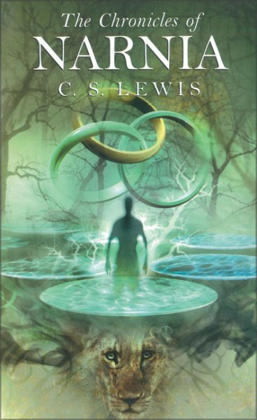
Linda: Little Princes: One Man's Promise to Bring Home the Lost Children of Nepal by Conor Grennan $25.99 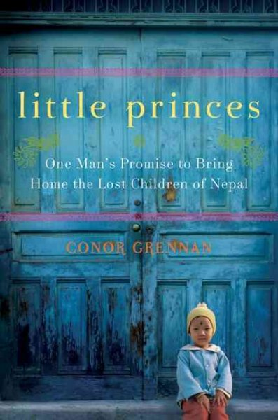 Linda says: Tired of the corporate world, Conor Grennan takes a year off to do a planned world trek. Not wanting to seem like a slacker, his first stop is a planned short volunteer stint at Little Princes, an orphanage in Nepal. Conor discovers that the children are not orphans but victims of child trafficking, and he takes it upon himself to attempt to reunite the children with their parents. Conor paints with words such vivid images of loss, hope and the beauty and harshness of life in Nepal. If you liked Greg Mortenson's Three Cups of Tea, you'll love Little Princes.

Left Neglected by Lisa Genova $25 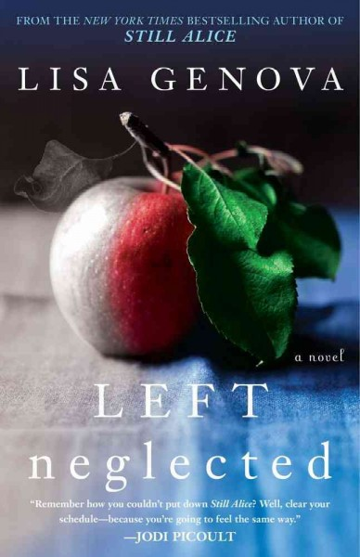 Linda says: Acclaimed author of Still Alice, Lisa Genova, has another hit on her hands with Left Neglected. Type A workaholic businesswoman, mother and wife Sarah Nickerson suffers a traumatic brain injury as a result of a car accident while using her cell phone on her way to work. A real medical condition called Left Neglect leaves Sarah unable to register anything on her body or in her mind involving the left side. During her months of rehabilitation, Sarah finally realizes what she has also neglected in her personal life.
Mennonite in a Little Black Dress: A Memoir of Going Home by Rhoda Janzen $14 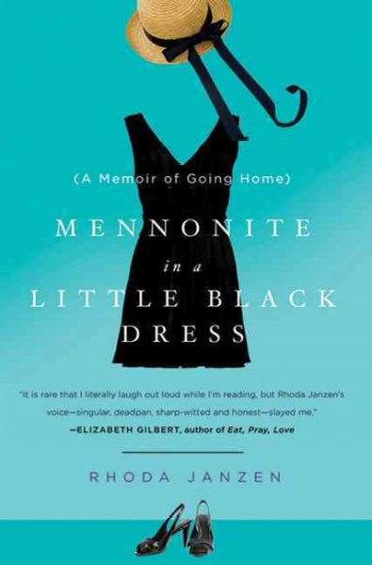
Cindie: Oracle of Stamboul by Michael David Lukas $24.99 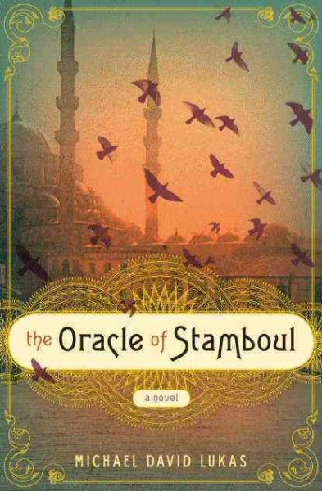 Cindie says: I'm nearly finished and just love it! It’s a kind of mythological, dreamy book filled with those incredible gems of sentences that take your breath away.

Sally: Mamba Point by Kurtis Scaletta $16.99
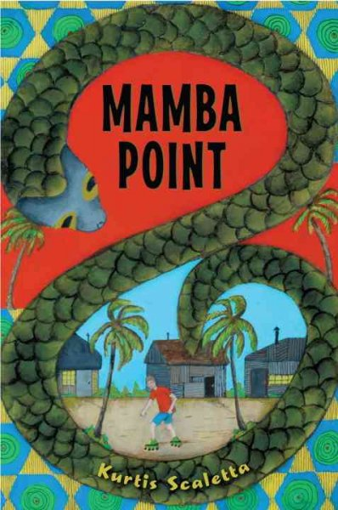
Pope Joan by Donna Woolfork Cross $15
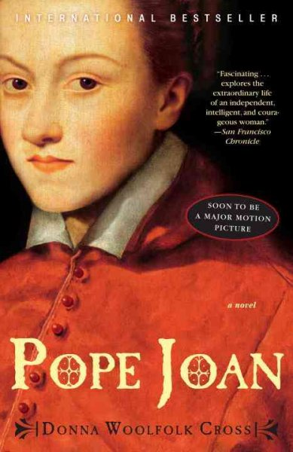
Zeitoun by Dave Eggers $15.95
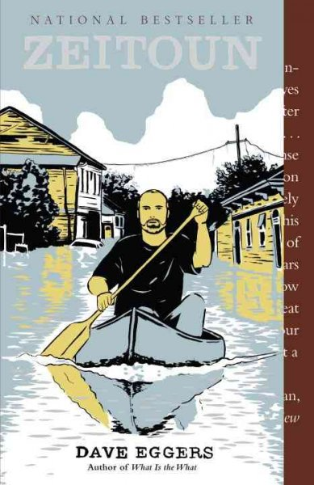

Jen:
Eating for Beginners: An Education in the Pleasures of Food from Chefs, Farmers, and One Picky Kid by Melanie Rehak $25
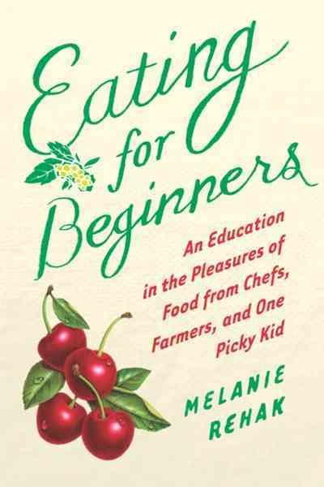 Jen says: I found this gem of a memoir about a woman who spends a year really getting to know her local food sources. She cooks in a restaurant that primarily uses local sources, and then visits those local sources (farm, fishing boat, etc). In the background, the author is struggling to get her son to eat ANYTHING. (He won’t eat pasta, meat, or chocolate, for example). The author has a great sense of humor

(even in her recipes. Usually I skip over the recipes in books, but these were worth reading). In a nutshell, think Julie Powell (the author of Julie and Julia) grown up.

Revolution by Jennifer Donnelly $18.99
 Jen says: Completely engrossing young adult book. There was a word I didn’t care for on the first page and I was tempted to move on to another book, but I decided to give it a chance by at least finishing the first page. There’s no way I’m putting it down now.

Jody:
See Youth Yak this month for Jody’s reads!

Gail: 19th Wife by David Ebershoff $15 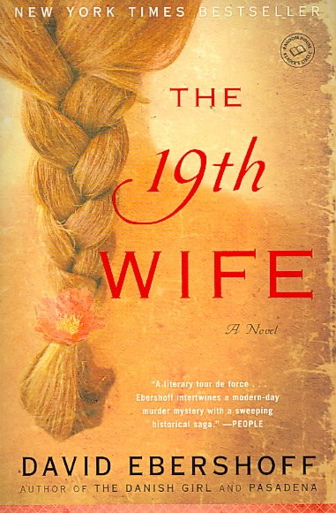 Flyaway: How a Wild Bird Rehabber Sought Adventure and Found Her Wings by Suzie Gilbert $14.99 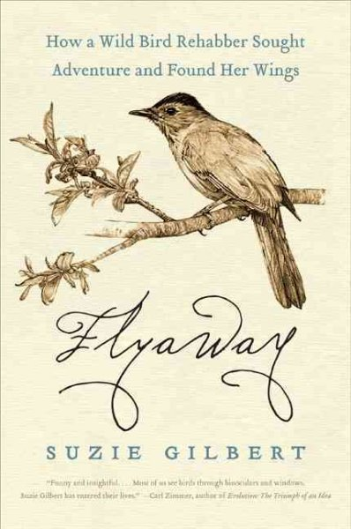 Gail says: A neat book about a bird rehabber.

Dewey's Nine Lives: The Legacy of the Small-Town Library Cat Who Inspired Millions by Vicky Myron $19.95 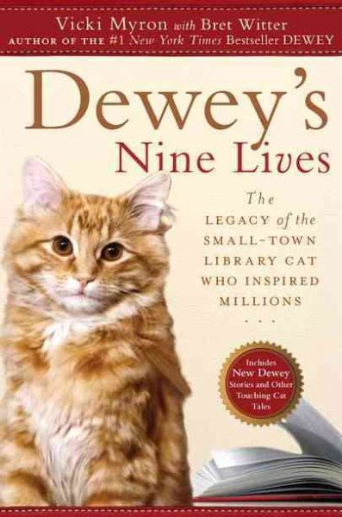*Note from Jen: If your book group decides to read this, be sure you know WHICH Dewey you’re reading. There are 4 Dewey books, all by the same author about the same cat. Barefoot in Baghdad: A Story of Identity--My Own and What it Means to be a Woman in Chaos by Manal M. Omar $14.99 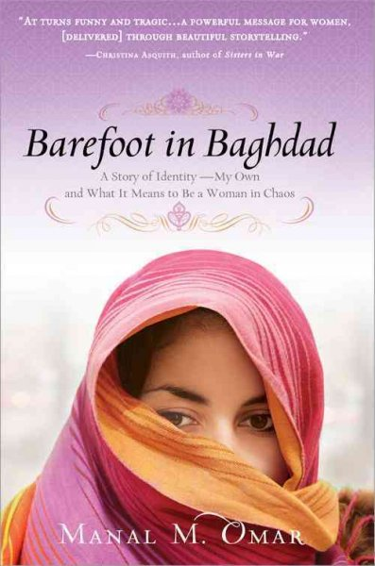 Capirotada: A Nogales Memoir by Alberto Alvaro Rios 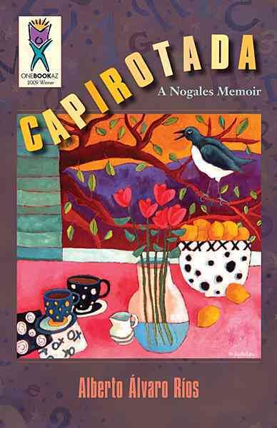 Gail says: One Book Arizona Pick in 2009 *Note from Jen: This book has gone out of print, but we can track down a used copy for you if you’re interested.
Cleo by Helen Brown $15.95 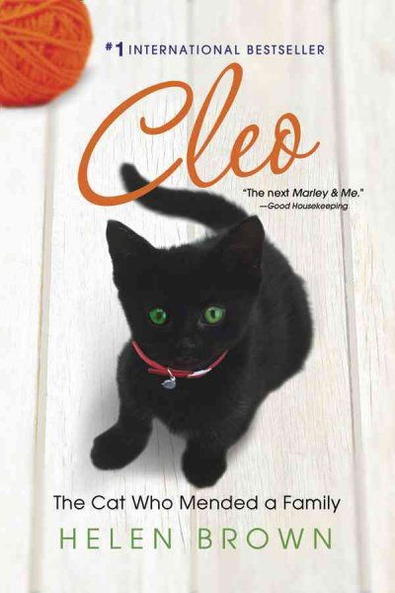

Youth Yak
Recommendations by Jody!
Huge Harold by Bill Peet $8.95
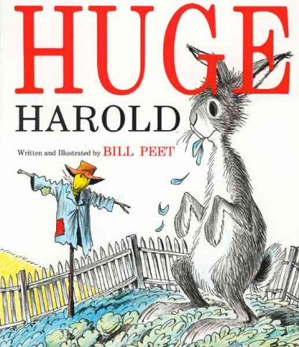
Fancy Nancy Poet Extraordinaire by Jane O’Connor $12.99
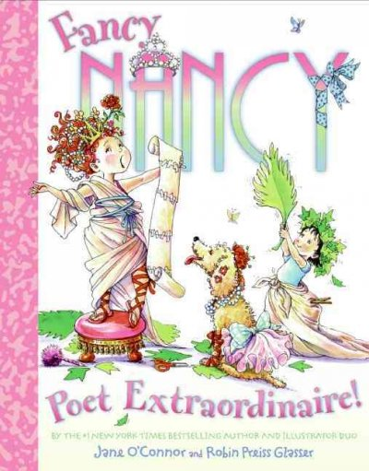
Giraffes Can’t Dance by Giles Andreae $9.95 (paperback with CD) or $16.99 (hardcover) 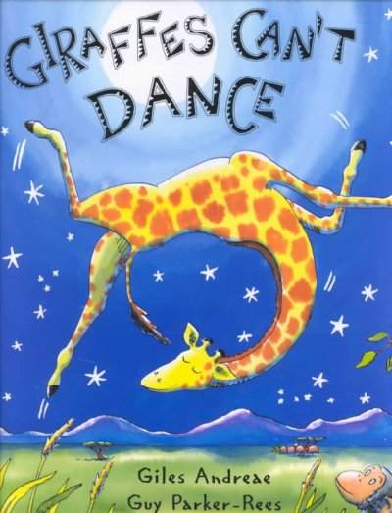
Otis by Loren Long $17.99
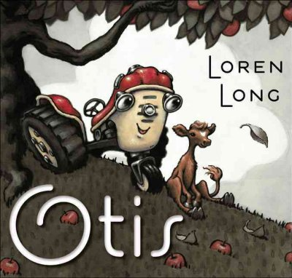
The Earth Book by Todd Parr $9.99


Attention Young Writers! What can YOU do with this sentence:
S/he did SO not want to be here, especially when....
The Park Rapids Library is again sponsoring a writing contest! If you come up with a winning story, it's worth $20 Chamber Bucks and fame! Call the Park Rapids Library 218-732-4966 for more info!

Book Group Reads
Beagle Books Womens Book Group
Wednesday, February 9th at 6PM:
Major Pettigrew’s Last Stand by Helen Simonson $15
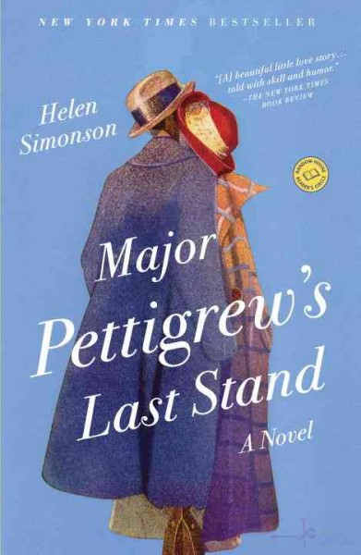

Beagle Books Mens Book Group
Tuesday, February 15th at 8AM:
Wordy Shipmates by Sarah Vowell $16
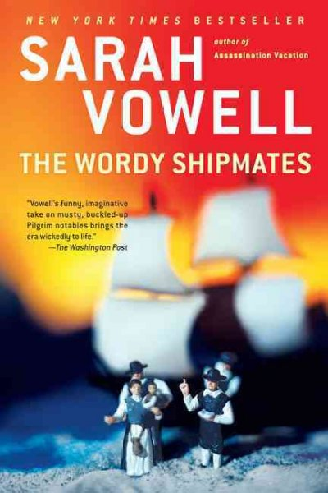

Blue Stocking Society
Lottery by Patricia Wood $14
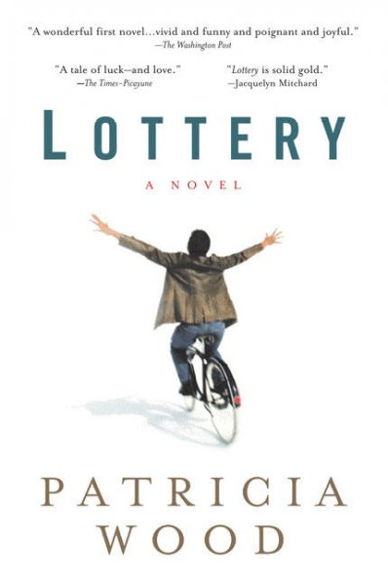

Gail’s Arizona Book Club
How Starbuck's Saved my Life by Michael Gates Gill $13 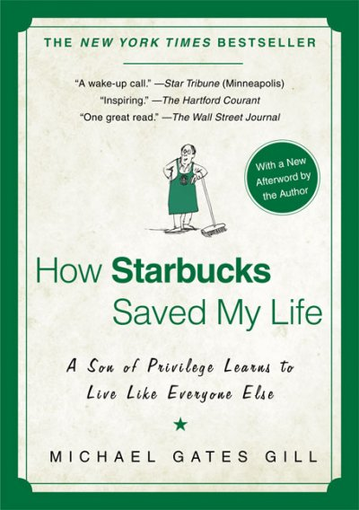
Note from Gail: For any of you that are snowbirds in Arizona and having book club withdrawal,
there is a book club meeting the 1st and 3rd Wednesday of each month at my RV Park. The address is:
Golden Sun RV Resort
999 West Broadway
Apache Junction, AZ 85120
The club discussed Loving Frank by Nancy Horan in January. As a result of the discussion we decided to take a trip to Scottsdale to visit Taliesin West. This was one of Frank Lloyd Wright's homes and still is an architectural school.

Park Rapids High School Book Club
The Chosen One by Carol Lynch Williams $8.99
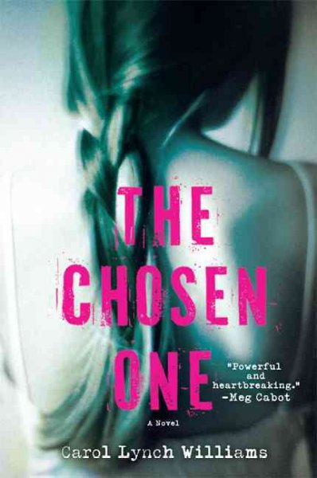 This group is led by one of our summer staff, Susan, who works as the high school librarian during the school year.

Annoying Blank Space

