HAPPY NEW YEAR!


Our Favorite Holiday Story
For those of you who’ve had us gift wrap a book for you, you know that we always include a foil paw print sticker on the package. We wondered if anyone really noticed. It’s been confirmed that at least one person has taken notice. Anne Morgan told us the following story:
My 6-year old granddaughter came to my house and saw wrapped packages under the Christmas tree. She started jumping up and down and cheering, “Beagle Books! Beagle Books!” I asked her, “How do you know I’ve been shopping at Beagle?” She told me, “The paw print sticker!”

Events
 Night-In
This is an event we did for the first time last January and had such a good time, we’re doing it again this January! All book group members (or anyone interested in joining a book group) of any book group are invited to Beagle Books on Saturday, January 16th at 7PM for an evening of chocolate, wine, cheese, cider, PRIZES, and of course, book talks! Mark it on your calendar now, you don’t want to miss this!

Skype with Maggie Stiefvater
We’re having an author event with Maggie Stiefvater, young adult author of Shiver, Lament, and Ballad on Wednesday, January 20th at 3:45PM. There is a teen book group at Park Rapids High School that read Shiver. They will be coming to Beagle Books for the skype event with

the author. (Skype is a technology using a live video camera between computers, so that two parties can communicate – like being on the phone, but you can also see each other!) The event is open to the public, but of course, the teen book group gets front row carpet!
Midwest Connections Picks  January Picks:
Happy: A Memoir by Alex Lemon $25 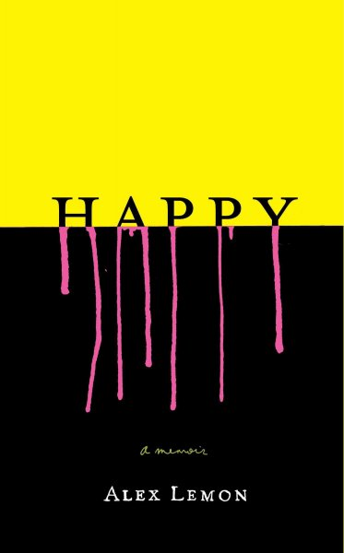Jen says: Way back in October, we attended the Midwest Booksellers Association’s trade show. Sally and I had the honor of sharing a table with author Alex Lemon over supper one evening. At the trade show, we receive a plethora of books. Alex Lemon’s Happy was the first one I read. In fact, I had nearly finished it by the time I returned home at the end of the trade show weekend. Like Alex in person, Happy gives us all (or seemingly all) of Alex: the boisterous partying college student; the scared young man who fears he might not survive brain surgery; the not so honorable boyfriend; the son; and all other parts of him. In the past, Alex Lemon has published prose poetry. The voice in Happy is one that is so accessible and so succinct. Not every poet is able to write a memoir, but Alex Lemon has done a terrific job.
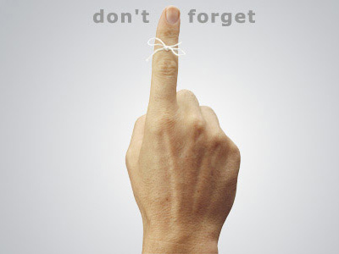Night-In is Saturday, January 16th at 7PM

Out of the Northwoods: The Many Lives of Paul Bunyan by Michael Edmonds $24.95
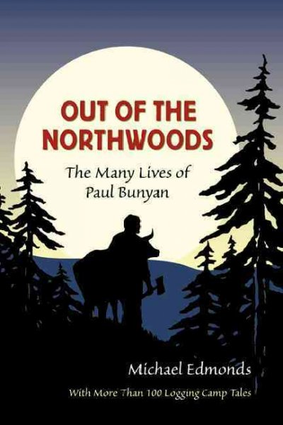
*This was also a pick in the Midwest Booksellers 2009 catalog. If you haven’t redeemed your 10% off one catalog book coupon in the back of the catalog yet, you have until January 31st, 2010 to do so!
Every American has heard of the lumberjack hero Paul Bunyan and his big blue ox. For 100 years his exploits filled cartoons, magazines, short stories, and children’s books, and his name advertised everything from pancake breakfasts to construction supplies. By 1950 Bunyan was a ubiquitous icon of America’s strength and ingenuity. Until now, no one knew where he came from—and the extent to which this mythical hero is rooted in Wisconsin.
Out of the Northwoods presents the culture of nineteenth-century lumberjacks in their own words. It includes eyewitness accounts of how the first Bunyan stories were shared on frigid winter nights, around logging camp stoves, in the Wisconsin pinery. It describes where the tales began, how they moved out of the forest and into print, and why publication changed them forever.
By sifting through the unpublished manuscripts of early editors of the tales, Michael Edmonds unearths dozens of authentic Bunyan stories told aloud by lumberjacks between 1885 and 1915. Edmonds recounts a saga of lies, hoaxes, thefts, and greed that transformed the private jokes of

working-class loggers into mass-market picture books for toddlers. The central characters include a genial northern Wisconsin con-man who claimed he invented the lumberjack hero, a spunky University of Wisconsin co-ed who collected the tales in logging camps in 1915, and a mild-mannered curator of the Wisconsin Historical Museum who lifted federal documents to keep the truth alive.
Part bibliographic mystery and part social history, Out of the Northwoods explains for the first time why we all know and love Paul Bunyan. An appendix includes more than 100 original tales about Bunyan, his camps, his crew, and his adventures taken directly from loggers early in the last century.
Night-In is Saturday, January 16th at 7PM
Staff Picks Linda: Julie and Julia by Julie Powell $14.99
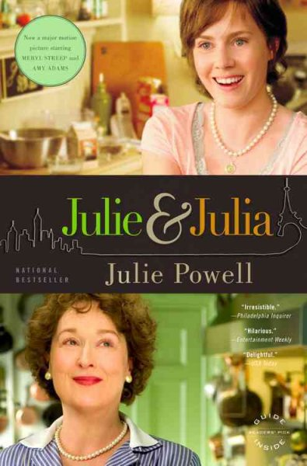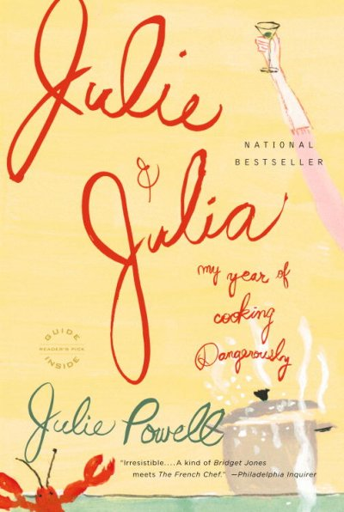

 Newsletter Coupon 
20% off any one book.

Night-In is Saturday, January 16th at 7PM

Jennie: Ditching Mr. Wrong: How to End a Bad Relationship and Find Mr. Right by Nicholas Aretakis $24.95 
An Hour to Live, an Hour to Love: The True Story of the Best Gift Ever Given by Richard Carlson and Kristine Carlson $9.95

Gail:
Blind Your Ponies by Stanley Gordon West $16

Gail says: A great story about a small town basketball team who fights their way to the top.
Note from Jen: Stanley Gordon West is an author that has never been on the mainstream bestselling book lists, but he’s an author we keep in stock because our customers (male and female; young, old & in-between) love his books. A number of high school teachers use his books in their classroom because the students will really engage in good discussions. If you’ve never read one of his books, you might want to give one a try!
Home Safe by Elizabeth Berg $15
This "S"old House by Diane Keyes $14.95 Gail says: This is tips on how to stage your home to sell quickly even in a slow market.
The Children's Blizzard by David Laskin $13.95 Gail says: In 1888, a blizzard hit across the Midwest so suddenly that no one was prepared. It is a true story that is very well written, a must for all that make the Midwest their home!

Jennifer: Remedies by Kate Ledger $24.95  Jennifer says: I LOVE this book! It is SO well-written! This is a new author that I am hoping will devote most of her time to writing novels. (This one took ten years to write, I’m not sure I can wait another ten!) The author so unabashedly delves into the consequences of grief left ungrieved. Simon and Emily Bear is a middle-aged couple with one teenage daughter. Prior to the daughter’s birth, the couple had a son who died as an infant. Simon, a doctor, buries himself in work. When Simon thinks he’s found a cure for chronic pain, he becomes so immersed in his work that he teeters dangerously close to the edge of insanity. Emily has repressed her emotions so completely that it is only with the help of a former lover that her stuffed feelings have any chance of airing. This is not a plot-driven story, but if you can fall in love with the beauty of well-written sentences and the incredible evolution the human soul can make, you must read this!
Healing after Loss: Daily Meditations for Working Through Grief by Martha Whitmore Hickman $10

Bob:
The Composer is Dead by Lemony Snicket $17.99
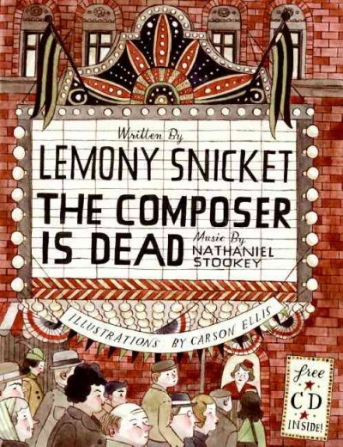

Cindie:
Dean and Me: A Love Story by Jerry Lewis $15.99 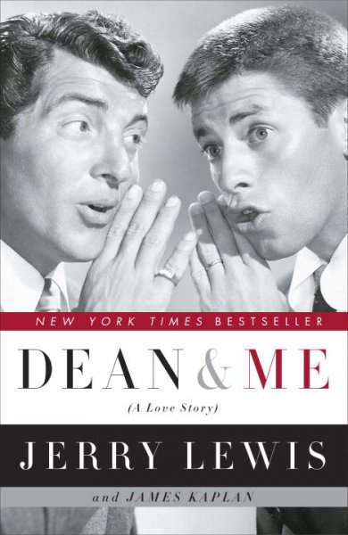Cindie says: My sister and I used to sneak up late at night and watch Martin and Lewis movies. Lewis's memoir is funny, sad and satisfying.
Fall Pictures on an Abandoned Road by Richard Sederstrom $12.50 *This is a book of poetry by local poet, Richard Sederstrom!

Sally:
Alice I Have Been by Melanie Benjamin $25
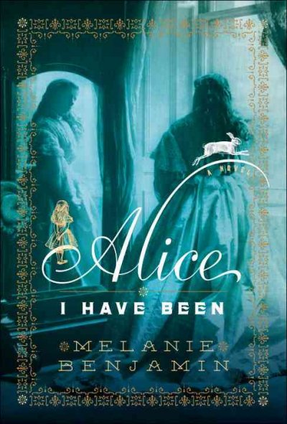
Sally says: This book is a novel which blends historical facts with imagination as it explores the life of Alice Pleasance Liddell--the Alice for
whom Lewis Carroll wrote Alice in Wonderland. I found it to be a very interesting book. And I wonder, did I ever read Alice in Wonderland, or was my exposure through the Disney movie?
The New Frugality by Chris Farrell $26
Sally says: You may be familiar with the author from public radio or his newspaper column. The New Frugality is Farrell's response to the Great
Recession. He writes in very accessible language, describing a paradigm shift toward a lifestyle based on core values, sustainability, and buying "the best you can afford but the least you need." A great resource for anyone reassessing their financial life--and isn't that all of us these days?

Night-In is Saturday, January 16th at 7PM

Youth Yak
Cindie’s Pick:
Carl's Snowy Day by Alexandra Day $12.99
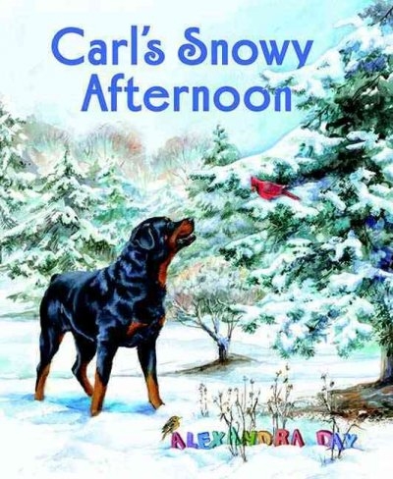 Cindie says: Alexandra Day took a long hiatus from the Good Dog Carl books and had even said she was finished with them. Now there are two more! Carl's Summer Vacation and Carl's Snowy Day. These books have always been among our family's favorites and they are now granddaughter Jager's favorites, too, when she comes to visit her Granny!
Jennifer’s Pick:
Peter and the Sword of Mercy $29.99 on audio (the hardcover is $18.99)
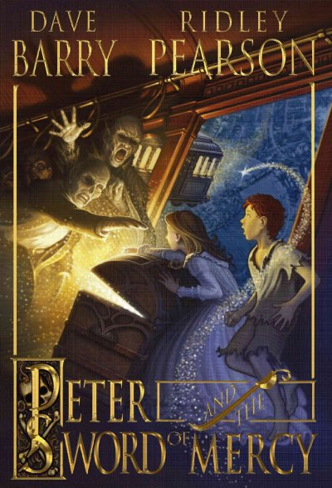 Jennifer says: This is the 4th book in Dave Barry and Ridley Pearson’s Peter (as in Peter Pan) series and I’m loving it! If you haven’t discovered this series, get reading! To make the reading even better, I’m reading it via audio book and the reader for this series is Jim Dale, the same man who did the Harry Potter books. When it comes to audio books, Jim Dale is KING!!

Night-In is Saturday, January 16th at 7PM

Book Group Picks
Beagle Books Womens Book Group
Saturday, January 9th at 10AM:
Angela’s Ashes by Frank McCourt $16
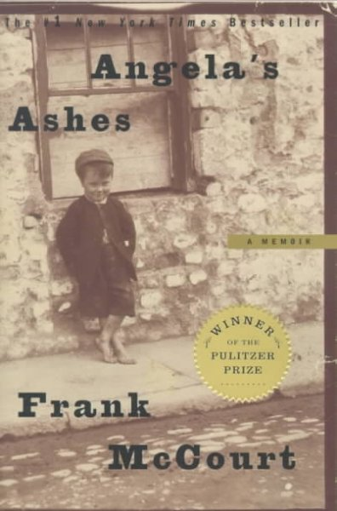

Beagle Books Mens Book Group
Tuesday, January 19th at 8AM:
Wolf at Twilight by Kent Nerburn $15.99



Night-In is Saturday, January 16th at 7PM

Night-In is Saturday, January 16th at 7PM

Night-In is Saturday, January 16th at 7PM

Night-In is Saturday, January 16th at 7PM

Night-In is Saturday, January 16th at 7PM

Night-In is Saturday, January 16th at 7PM

Night-In is Saturday, January 16th at 7PM

Night-In is Saturday, January 16th at 7PM

Night-In is Saturday, January 16th at 7PM

Night-In is Saturday, January 16th at 7PM

