NaNoWriMo Time!

It’s November and that means NaNoWriMo time! Every year, you’re invited to take the challenge to write 50,000 words in 30 days! We’re not talking polished prose, we’re talking spitting out 50,000 words any way you can. Why bother? Your inner editor, who is often the culprit of writer’s block, has to be sent away so that you, the writer, can just write. Not to worry, we have a lovely kennel at Beagle Books where we house the inner editors for the month of November. We give them red pens and newspapers to keep them content. In the meantime, you’re able to write unhindered! You won’t end up with the next great American novel, but you will end up with a blob that can be morphed into a rough draft which can be polished and polished and polished and eventually become the next great American novel (or epic poem, or whatever you choose). It’s FREE, it’s FUN, and it gives you a great sense of accomplishment. Cindie, Beagle Books staff and Jackpine Writers Bloc member, will even print a frame-able certificate for all the winners at the end. We won’t read your work (unless you want us to), this is completely on the honor system. You say you wrote 50,000 words, we believe it! To sign up or for more information, contact Cindie at Beagle Books: 237-2665 or email Cindie at: cindiee@hotmail.com (yes, that’s c-i-n-d-i-e-e, it’s best if you just copy and paste the link).

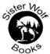 Newsletter Coupon 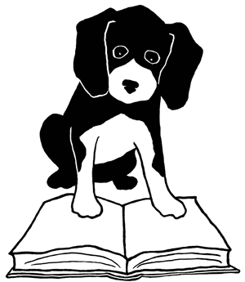
20% off any one book.

Catalog
Make sure you treat yourself to a copy of this year’s Midwest Bookseller’s catalog. It’s loaded with great books. Not sure what book to get your favorite pet lover this holiday season? Check out page 16 of the catalog! Pick up your copy at Beagle Books or if you’re a local subscriber to the Park Rapids Enterprise, you will get a catalog in your newspaper on Nov. 22nd. We have stocked many of the catalog’s books and of course, if we’re out of a title you need, we will order it in for you. There’s even a coupon inside the catalog good for any book in the catalog. You can’t go wrong!

Farewell to Tony Hillerman
On Sunday, October 26th, the book community lost a well-loved writer when Tony Hillerman died at the age of 83. Hillerman penned the Navajo Tribal Police mystery novels. Thank you to Mr. Hillerman for your contributions. We honor your work and your spirit.

From YOU
We asked you to tell us what your book group is reading and Karen in Missouri sent us her book group’s picks! Thanks Karen! Here’s what’s on their reading list:
The Devil in the White City by Erik Larson
Olive Kitteridge by Elizabeth Strout
The Guernsey Literary and Sweet Potato Peel Pie Society by Mary Ann Schaffer and Annie
Barrows
Dog Years by Mark Doty
Daughter of Fortune by Isabel Allende

We’d love to hear what YOUR group is reading!

Midwest Connections Picks

November Picks:
(Check Staff Picks to see who read two Midwest Connections Picks this month and what she had to say!)

Dewey: The Small-Town Library Cat Who Touched the World by Vicki Myron
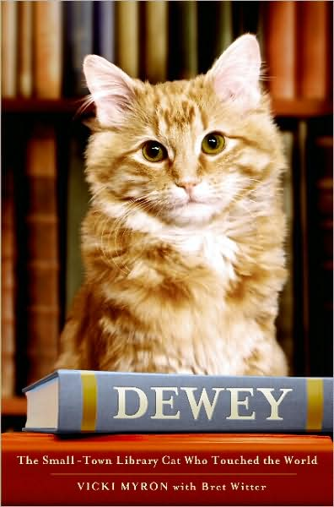
Dewey is the heartwarming story of Dewey Readmore Books, the beloved library cat of Spencer, Iowa, as told by his owner and companion of nineteen years, Vicki Myron, the librarian who found him on a frigid January morning when he was abandoned as a kitten in the book drop slot. It is also the story of a remarkable small town, which burned down at the beginning of the Depression, only to rebuild itself, and which was almost shuttered during the farm crisis of the 1980s, before regrouping and rededicating itself to small town American values. Dewey's local charm and worldwide fame became a symbol of hope for this recovering town. Through Dewey's antics, we come to know and love many of the colorful and inspiring people of Spencer. But perhaps the most inspiring person in Spencer is Vicki Myron herself, a single mother who survived the bankruptcy of her family farm and working in a box factory to put two of her brothers through college to become one of the leaders of the Iowa library system. (Grand Central Publishing). $19.99

A Dog Named Christmas by Greg Kincaid
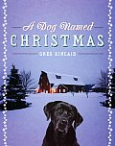
When Todd McCray, a developmentally challenged young man still living on his parents’ Kansas farm, hears that a local animal shelter is seeking temporary homes for its dogs during the days leading to Christmas, he knows exactly what he wants for the holidays. His father objects, but Todd’s persistence quickly wins out. Soon the McCrays are the short-term foster family for a lovable pooch the young man names Christmas.
But what about all the other dogs who will be forced to spend the Yuletide season in cages? In the days that follow, Todd uses his special gifts of persuasion to encourage his hometown to
participate in the “Adopt a Dog for Christmas Program.” What follows from his small act of kindness will teach his family, and his community, about peace on earth and good will toward all—and animals. (Doubleday Books). $14.95

This Water Goes North by Dennis Weidemann
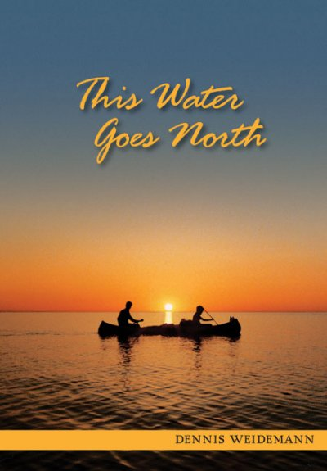

From the tranquil farmland waters of Minnesota to the treacherous wilderness rapids of Manitoba, four young men in two old canoes experience an adventure that every kid talks about, but few take. With leaky tents, little experience, and no TV cameras or big-time sponsors, the lads set out

in 1979 to paddle 1,400 miles north to Hudson Bay. Why? Why not! Driven by a youthful sense of adventure, they took the chance of a lifetime just to see what lay around the next turn. Sit in their canoe as they glide through smooth waters and survive rushing rivers. Experience with them the desolation of true wilderness and go on humorous escapades with local characters. With graceful storytelling, Dennis Weidemann weaves this richly diverse tale of near disasters, splendid sunsets, bootleggers, Mounties, polar bears, and the indomitable spirit of youth. Share the dream that still lives, and that will surely inspire others.
(Manitenahk Books). $21.95
Staff Reads Bob- You're Not the Boss of Me: Adventures of a Modern Mom by Erika Schickel
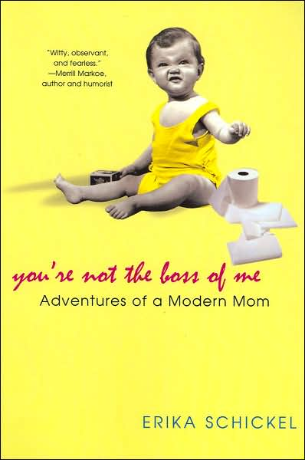
Brian- Paper Towns by John Green

Brian says: Best book ever!
An Abundance of Katherines by John Green
Me Talk Pretty One Day by David Sedaris

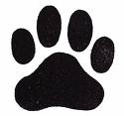

Cindie- No Plot, No Problem by Chris Baty The Artist’s Way: A Spiritual Path to Higher Creativity by Julia Cameron
Jennifer- Zookeeper’s Wife by Diane Ackerman 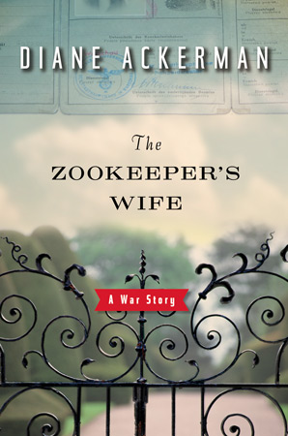The Artist’s Way: A Spiritual Path to Higher Creativity by Julia Cameron Inkspell by Cornelia Funke on audio
Hannah- Masterpiece by Elise Broach 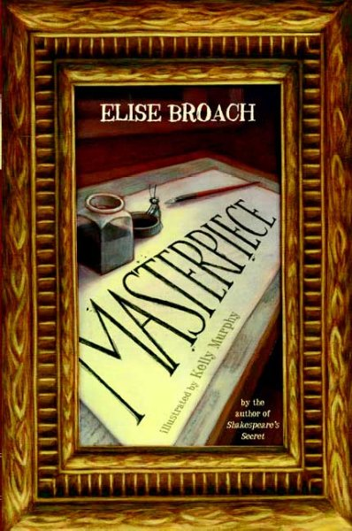Hannah says: I absolutely loved this book! It is a clever and sweet story about the friendship between a boy and a beetle. Really fun read.
Sovay by Celia Rees , Roll of Thunder, Hear My Cry by Mildred Taylor, The Witches by Roald Dahl
The Jungle Book by Rudyard Kipling , His Dark Materials by Philip Pullman, Number the Stars by Lois Lowry, Bud, Not Buddy by Christopher Paul Curtis (Guess who’s an English Lit major??) 

Gail- Dewey by Vicki Myron Gail says: I loved this book. No, I don't have a cat but I grew up just 40 miles from Spencer, Iowa and having spent 18 years as a librarian, this was the book for me. Someone threw a kitten in the library drop box on a night when it was -15 degrees below zero. Dewey, as he was named by the library patrons, survived with loving care from the librarians, and spent the next 18 years of his life greeting library patrons each morning as the library opened. He loved people and seemed to know when a person was feeling down. He also had a special relationship with children with special needs. This is a true story of a very special cat and the effect he had on the people of Spencer. This Water Goes North by Dennis Weidemann Gail says: The author is a Minnesota writer who tells the true story of three friends that canoed with him on the Red River. They started south of Fargo and traveled to Hudson Bay. A great adventure and the writing is well done.
Jody- My Stroke of Insight: a Brain Scientist’s Personal Journey by Jill Bolte Taylor Prospering Power of Love by Catherine Ponder

Linda- The Guernsey Literary and Potato Peel Pie Society by Mary Ann Shaffer and Annie Barrows 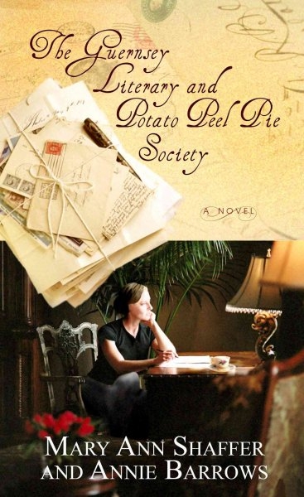 Linda says: Loved it!!! The Zookeeper's Wife on audio
Run by Ann Patchett, Sweetheart (the sequel to HeartSick, one of the best psychological mysteries I've read in a long time) by Chelsea Cain
Rhoda- Without Reservations: the Travels of an Independent Woman by Alice Steinbach 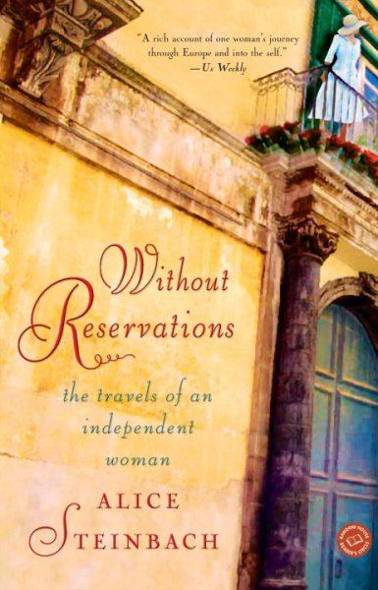 Rhoda says: Very good! Inspiring biography of a woman who took a sabbatcial from her career as a journalist and escaped to Paris. Burning the Map by Laura Caldwell
Sally- To Siberia, Per Petterson
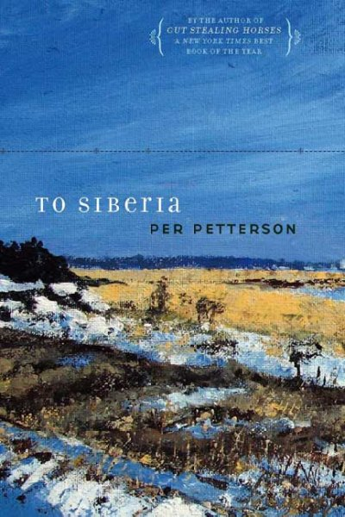
Wicked by Gregory Maguire on audio
Hard Truth by Nevada Barr
Green Housekeeping by Ellen Sandbeck

Youth Yak
by Jen
Every month, I ask staff to tell me what they’re reading for the Staff Picks portion of the newsletter. This month, Cindie gave me her list and then added: “…and for fun-- two Jan Brett books Gingerbread Baby and the new Gingerbread Friends. Classic Brett. Wonderful!!! I'm a HUGE Jan Brett fan.” Her enthusiasm infected me, so I’m showcasing them this month in Youth Yak.

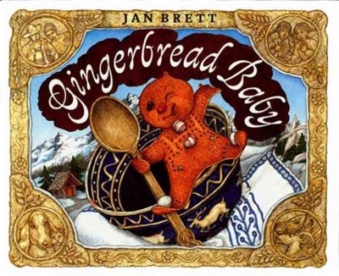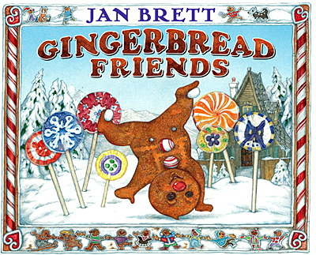

Gingerbread Baby:

Remember how the Gingerbread Boy is eaten by the fox? Well, not this Gingerbread Baby in a delicious twist to a favorite old tale. It all begins when Matti opens the oven too soon and out jumps a cheeky little Gingerbread Baby. He leads Matti's mother and father, the dog and the cat, and a whole colorful cast of characters on a rollicking chase through the village and into the forest, staying just out of reach, daring them to catch him along the way. But Matti's not with them. He's at home in the borders making what turns out to be a gingerbread house into which the Gingerbread Baby runs. Only Matti knows he is safely inside. And readers will too when they look under the lift-the-flap gingerbread house at the end of the story, and there he is!

Gingerbread Friends:
In this delicious sequel, the Gingerbread Baby happens upon a bakery, where he dances and prances in front of a sugar cookie girl, trying to make friends. But she just stares and doesn’t say a word, like all the other sweet treats he tries to meet. Discouraged, the Gingerbread Baby runs home, chased by a long line of hungry creatures, where Mattie has a fantastic surprise for him—gingerbread friends that fill a giant fold-out page. Irresistible images inside the confectionery and outside in the snowy Swiss countryside will delight Jan Brett fans.

Beagle Books Book Group Reminders

Beagle Books Men’s Group meets the 3rd Tuesday of the month at 8AM. On November 18th, they’ll discuss Audacity of Hope by Barack Obama.
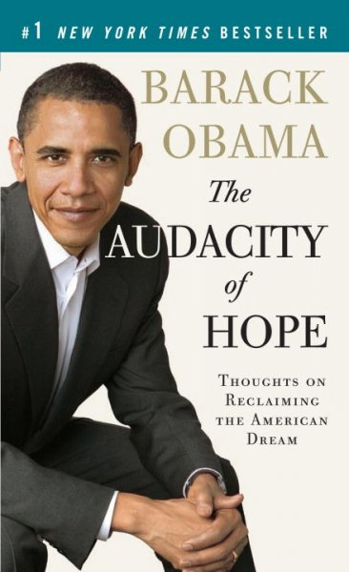

The Beagle Books Women’s Group meets the 3rd Thursday of the month at 6PM. On November 20th, they’ll discuss Zookeeper’s Wife by Diane Ackerman.

