- Check your device to see you if already have the Kobo app. It looks like: or 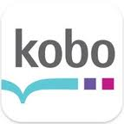 (background can be any color). If you DO, delete it. (Yes, really).

- Go to http://beagleandwolf.com/

- Click on the blue square with the words “Never Stop Reading: We Now Sell Kobo e-books” and you’ll see:

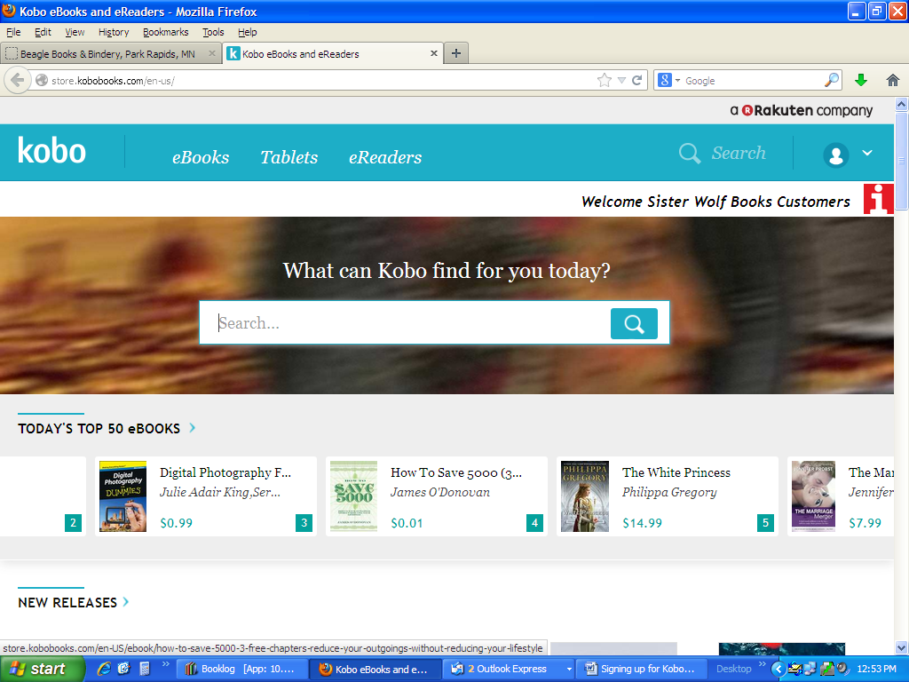

- Click the icon of a person: 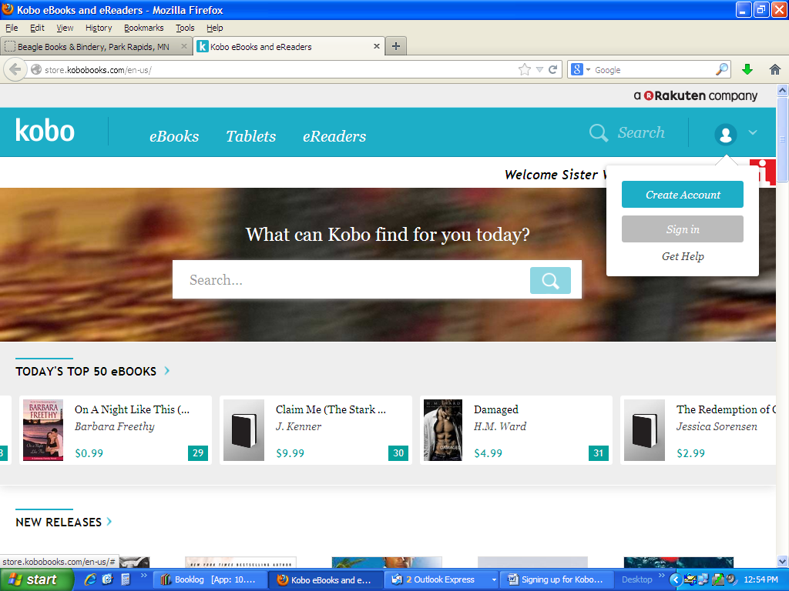

- Then click the grey “Sign in” button and you will see:
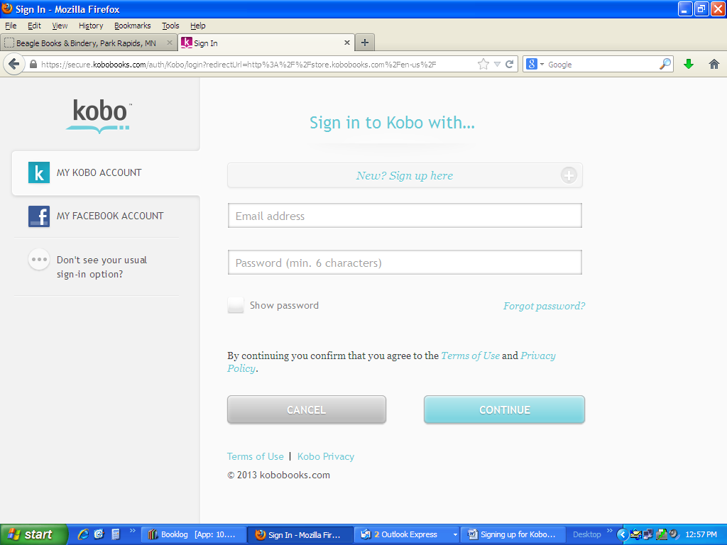

- Click the blue words: “New? Sign up here”.
- At the next screen, filled in the required fields and click “Continue” (Note! If you have ever had a Kobo acct before, do NOT use the same email address you used for that acct in the past)

- 24 hours later, call Jen at Beagle: 237-2665 and ask her to verify that your account has been established. Once she’s verified it…….HAVE FUN SHOPPING!!! (Go to BeagleAndWolf.com, click on the Kobo link, and sign in)

