Happy Birthday Dr. Seuss!

“Today You are You, that is Truer than True. There is no one alive who is Youer than You.”
March 2 was Dr. Seuss’s birthday!
We hope you read and re-read Seuss not only in March, but all year!

Events:
Did you miss our recent back-to-back book signings?? Darby Nelson, author of For the Love of Lakes (short-listed for this year’s Minnesota Book Awards!) was here on March 6th and Jess Lourey, author of Murder-by-the-Month series was here on March 7th. If you missed these signings, we do have signed stock left in the store.

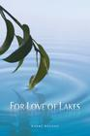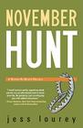

Chili Challenge 
Once again, Jen participated in the Annual Chili Challenge to raise money for the local Food Shelf! Thanks to Jennie Anderson, who came up with this year’s chili name, Bow-Wow! Chili. (If you’re wondering, the chili’s bark was worse than its bite.)

Midwest Connections Pick 
March Pick: Finding Our Way Home by Alex George $25.95 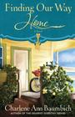 When principal ballerina Sasha Davis suffers a career-ending injury at age thirty-eight, she leaves her Boston-based dance company and retreats to the home of her youth in Minnesota. But Sasha’s injuries limit her as much as her mother’s recent death haunts her. Concluding she can’t recover alone, Sasha reluctantly hires a temporary live-in aide. Enter the übercapable Evelyn Burt. As large-boned as Sasha is delicate, Evelyn is her employer’s

opposite in every way. Small town to Sasha’s urban chic, outgoing to Sasha’s iciness, and undaunted where Sasha is hopeless, nineteen-year-old Evelyn is newly engaged and sees the world as one big, shiny opportunity.
Evelyn soon discovers Sasha needs to heal more than bones. Slowly, as the wounds begin to mend and the tables tilt, the two women form an unlikely alliance and discover the astounding power of even the smallest act done in the name of love. Finding Our Way Home is a story of second chances and lavish grace.
Staff Picks
Hannah:
Pandemonium by Lauren Oliver
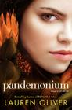 Hannah says: The sequel to Delirium - I've been waiting forever for this!

The Selection by Kiera Cass
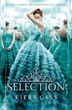

Wanderlove by Kristin Hubbard


Starters by Lissa Price
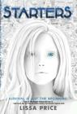 Hannah says: Awesome post-apocalyptic novel.
Grave Mercy by Robin LaFevers
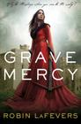
Jamie:
American Dervish by Ayad Akhtar
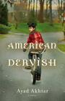 Jamie says: Hayat Shah is a teenage boy living in the Midwest. Although he is looked at as a Muslim, he and his family does not
practice the religion until his Auntie comes to live with them. Once Auntie Mina and her son move to America, Hayat learns about the Quran, his faith, his family, himself, as well anti-Semitism.
A Good American by Alex George
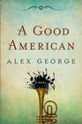 Jamie says: I loved this book! Alex George paints a beautiful story of family and

history starting with Jette and Frederick. These two re-start their lives by leaving Prussia and immigrating to Missouri. The story
continues through the generations and is intertwined with love, heartache, history, and music. As soon as I finished this book, I wanted to re-read it.
Defending Jacob by William Landlay
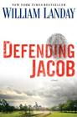

Linda:
Steve Jobs by Walter Isaacson
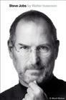 Linda says: From orphan to one of the most creative men the modern-day world has ever known, this book kept me riveted as it outlined Jobs rollercoaster life of creativity. After reading this, it's not difficult for me to understand how Apple just became the hottest company around.
Defending Jacob by William Landay
Linda says: How much do we really know about our family members? And can

violence be inherited through our genetic makeup? These two questions make for a rollercoaster ride of a read in Landay’s latest courtroom/mystery tale. Jacob, 14-year-old son of the Boston First Assistant District Attorney, has been charged with the murder of a classmate. Pitting legal expertise against the love of a father for his son made for a story I couldn’t put down.
Sally:
No One is Here Except All of Us by Ramona Ausbel
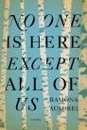 Sally says: This is the most captivating and beautifully written book I have read in a long time. It's set in a remote Jewish village during World War II. The villagers, at the suggestion of 11 year old Lena and with the help of a woman they call the stranger, decide to cut themselves off from the world and create a new world. The power of storytelling, community, and the imagination are among the themes of the book.

Jen:
A Good American by Alex George
Jen says: Love it!! I sent the author a message on Twitter and he sent back a playlist to accompany the book! Check it out for yourself!: http://www.playlist.com/agoodamerican

Next to Love by Ellen Feldman
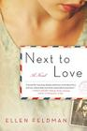
Game of Thrones by George R.R. Martin 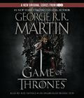 Jen says: Yeah, yeah – I’ve been reading this one for a while, but it’s very long and I’m listening to the audio!! (And LOVING it!!)

Gail:
The Zookeeper's Wife by Diane Ackerman
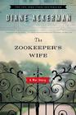
Snow Falling on Cedars by David Guterson
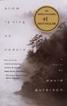
Plain Truth by Jodi Picoult
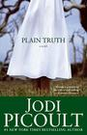

The Last Lecture by Randy Pausch
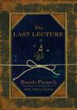 Gail says: Lots of good common sense in this one!

Youth Yak
by Hannah!
Here are a few Young Adult titles that are hitting shelves this month. They’ve all received great buzz and already come highly recommended!

Embrace by Jessica Shirvington
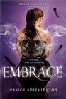 On her 17th birthday, everything will change for Violet Eden. The boy she loves will betray her. Her enemy will save her. She will have to decide just how much she's willing to sacrifice.
Dangerously exciting and darkly romantic, EMBRACE is a compelling novel of good and evil, seductive desires and impossible choices. A centuries old war between fallen angels and the protectors of humanity chooses a new fighter. It's a battle Violet doesn't want, but she lives her life by two rules: don't run and don't quit. If angels seek vengeance and humans are the warriors, you could do a lot worse than betting on Violet Eden.
Release Date: March 6

Wanderlove by Kristin Hubbard
Are you a Global Vagabond?
No, but 18-year-old Bria wants to be. In a quest for independence, her neglected art, and no-strings-attached hookups, she signs up for a tour of Central America—the wrong one. Middle-aged tourists are hardly the key to self-rediscovery.
So when Bria meets Rowan, devoted backpacker and dive instructor, and his outspoken sister Starling, she seizes the chance to ditch her group and join them off the beaten path. Bria's a good girl trying to go bad. Rowan's a bad boy trying to stay good. As they travel through Mayan villages and remote Belizean islands, they discover they're both seeking to leave behind the old versions of themselves. The secret to escaping the past, Rowan's found, is to keep moving forward. But Bria realizes she can't run forever. At some point, you have to look back.
Release Date: March 13
Dark Eyes by William Richter
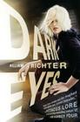 Wally was adopted from a Russian orphanage as a child and grew up in a wealthy New York City family. At fifteen, her obsessive need to rebel led her to life on the streets.

Now the sixteen-year-old is beautiful and hardened, and she's just stumbled across the possibility of discovering who she really is. She'll stop at nothing to find her birth mother before Klesko - her darkeyed father - finds her. Because Klesko will stop at nothing to reclaim the fortune Wally's mother stole from him long ago. Even if that means murdering his own blood. But Wally's had her own killer training, and she's hungry for justice.
The Girl with the Dragon Tattoo for teens, this debut thriller introduces our next big series heroine!
Release Date: March 20
Slide by Jill Hathaway
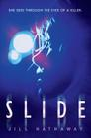 Vee Bell is certain of one irrefutable truth--her sister's friend Sophie didn't kill herself. She was murdered.
Vee knows this because she was there. Everyone believes Vee is narcoleptic, but she doesn't actually fall asleep during these episodes: When she passes out, she slides into somebody else's mind and experiences the world through that person's eyes. She's slid into her sister as she cheated on a math test, into a teacher sneaking a drink before class. She learned the worst about a supposed "friend" when she slid into her during a school dance. But nothing could have prepared Vee for what happens one October night when she slides into the mind of someone holding a bloody knife, standing over Sophie's slashed body.

Vee desperately wishes she could share her secret, but who would believe her? It sounds so crazy that she can't bring herself to tell her best friend, Rollins, let alone the police. Even if she could confide in Rollins, he has been acting distant lately, especially now that she's been spending more time with Zane.
Enmeshed in a terrifying web of secrets, lies, and danger and with no one to turn to, Vee must find a way to unmask the killer before he or she strikes again.
Release Date: March 27
Book Group Reads
Beagle Books Womens Book Group
Wednesday, March 8th at 7 PM –
Wingshooters by Nina Revoyr
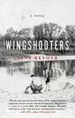
*Please note the time change as we will be meeting with the author via Skype.

Beagle Books Mens Book Group
Tuesday, February 15th at 8AM:
Rez Life: An Indian’s Journey Through Reservation Life by David Treuer
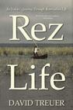.
*Don’t forget! 20% off on hardcovers for book group!

Blue Stocking Society
The Blue Stocking Society is not meeting in March. April’s pick is Nothing to Envy by Barbara Demick


