Dorset Festival of Authors and Artists
Go get your calendar. Right now. I mean it, get up, and go get your calendar (and a pen, too). Got ‘em? Ok, open the calendar, find June 25th and write in BIG LETTERS, in ink of course: DORSET FESTIVAL OF AUTHORS & ARTISTS Noon-8PM. There, as long as it’s in your calendar, you’re in for a real treat. On June 25th, Dorset will be bursting with talent (even more than usual). On June 25th, artists will be scattered along the boardwalk. Sister Wolf Books will be hosting authors in four two-hour shifts.
The following authors will be at the Festival (subject to change)!:
Noon – 2PM:
- William Kent Krueger - Cork O’Connor mystery series

- Carl Brookins - The Case of the Greedy Lawyers (mystery)
- Gayla Marty – Memory of Trees (memoir)
- Peter Bundy – Wild Garden (nature)
- Christopher Valen – The Black Minute (mystery)
- Candace Simar – Abercrombie Trail; Pomme de Terre (regional history)
- Larry Schung – Arrogant Bones (poetry)
2PM – 4PM:
- Todd Boss – Yellow Rocket (poetry)
- Dana Holm – Itasca State Park (photography)
- Kurtis Scaletta – Mudville (young adult)
- Bonnie Shallbetter & Arvid Williams – Hawk series (historical fiction)
- Nancy Leasman – Leatherwood Vinegary (wine-making)
- Joseph Plut – Conversations with Jon Hassler (biography)

- Freya Manfred – Swimming with a Hundred Year Old Snapping Turtle (poetry)
4PM – 6PM:
- Beth Solheim – At Witt’s End (mystery)
- Anton Treuer – Ojibwe in Minnesota (history)
- Brenda Whiteside – Sleeping with the Lights On (romance)
- Marisha Chamberlain – The Rose Variations (fiction) 
- Tom Stetzler – poetry
- Brian Duren – Whiteout (fiction)
- Mary Wingerd - North Country: The Making of Minnesota (history)
6PM – 8PM:
- Maureen Gibbon – Thief (fiction)
- Kent Nerburn – Wolf at Twilight
- Richard Sederstrom – Fall Pictures on an Abandoned Road (poetry)
- Jess Watnemo – Girlz in White Dresses (humor)
Wow! Aren’t you glad this event is on your calendar?!

Got Books, Will Travel
Recently, Jennifer has had requests from book groups to do book talks! (From Jennifer’s Dictionary of Terms: A Book Talk is a presentation of books by a passionate bookseller.) One group chose to travel to Beagle Books; another invited Jennifer into a home. Either way, we’re glad to do the same for YOU and YOUR book group! Call Sister Wolf and ask for Sally or call Beagle and ask for Jennifer. Be prepared to tell us a little bit about your book

group (what you’ve read in the past, what you’ve liked & hated, etc). We’ll schedule a time and
place. Goody bags will be provided. Books at the book talk will be available for sale.

Midwest Connections Picks May Picks:
The Stormchasers by Jenna Blum $25.95 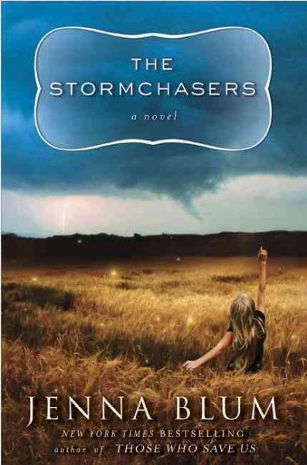 How far would you go to protect a sibling-and at what cost to yourself?
As a teenager, Karena Jorge had always been the one to look out for her twin brother Charles, who suffers from bipolar disorder. But as Charles begins to refuse medication and his manic tendencies worsen, Karena finds herself caught between her loyalty to her brother and her fear for his life. Always obsessed with the weather-enraptured by its magical unpredictability that seemed to mirror his own impulses- Charles starts chasing storms, and his behavior grows increasingly erratic . . . until a terrifying storm chase with Karena ends with deadly consequences, tearing the twins apart and changing both of their lives forever.
Two decades later, Karena gets a call from a psychiatric ward in Wichita, Kansas, to come pick up her brother, whom she hasn't seen or spoken to for twenty years. She soon discovers that Charles has lied to the doctors, taken medication that could make him dangerously manic, and

disappeared again. Having exhausted every resource to try and track him down, Karena realizes she has only one last chance of finding him: the storms. Wherever the tornadoes are, that's where he'll be. Karena joins a team of professional stormchasers-passionate adventurers who will transform her life and give her a chance at love and redemption- and embarks on an odyssey to find her brother before he reveals the violent secret from their past and does more damage to himself . . . or to someone else.
Dorset Festival of Authors & Artists is June 25th 12-8.
Deeply Rooted: Unconventional Farmers in the Age of Agribusiness by Lisa M. Hamilton $15.95
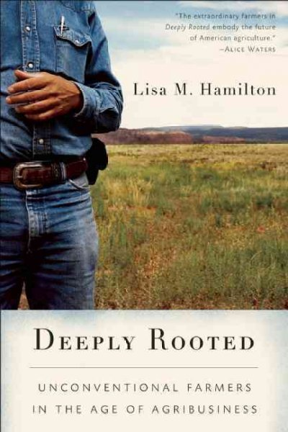 A century of industrialization has left our food system riddled with problems, yet for solutions we look to nutritionists and government agencies, scientists and chefs. Lisa M. Hamilton asks: why not look to the people who grow our food? In this narrative nonfiction book she tells three stories, of an African-American dairyman in Texas who plays David to the Goliath of agribusiness corporations; a tenth-generation rancher in New Mexico struggling to restore agriculture as a pillar of his community; and a modern pioneer family in North Dakota breeding new varieties of plants to face the future’s double threat: climate change and the patenting of life forms. In unique ways, these “unconventional farmers” reject the passive role

that modern agriculture has insisted they accept and instead reclaim their place as stewards of
the land and leaders within society.

Threads of history and discussion weave through
the tales, exploring how farmers have been pushed to the margins of agriculture and how that has led to the broken food system we grapple with today. These unusual characters and their extraordinary stories make the case that in order to repair the damage, we must bring farmers back to the table.
Dorset Festival of Authors & Artists is June 25th 12-8.
Horse-Drawn Days: A Century of Farming with Horses by Jerry Apps $24.95 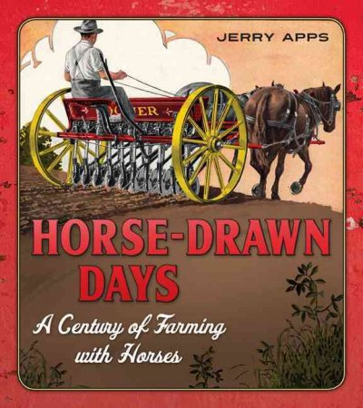 Before tractors or steam engines arrived on the farm, horses did all the heavy work. From spring plowing to the fall harvest, the mighty draft horse powered farms across the Midwest. Relied upon to complete a multitude of tasks, including towing threshing machines and plows, hauling milk to the local cheese factory, and pulling the family buggy to church each Sunday, these animals were at the center of farm life, cementing the bond between human and horse.
 Newsletter Coupon 
20% off any one book.

Wounded Knee: Party Politics and the Road to an American Massacre by Heather Cox Richardson $28.95 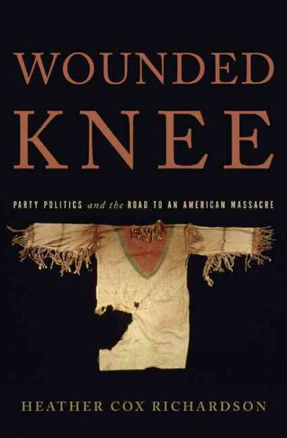 On December 29, 1890, American troops opened fire with howitzers on hundreds of unarmed Lakota Sioux men, women, and children near Wounded Knee Creek in South Dakota, killing nearly 300 Sioux. As acclaimed historian Heather Cox Richardson shows in Wounded Knee, the massacre grew out of a set of political forces all too familiar to us today: fierce partisanship, heated political rhetoric, and an irresponsible, profit-driven media. Richardson tells a dramatically new story about the Wounded Knee massacre, revealing that its origins lay not in the West but in the corridors of political power back East. Politicians in Washington, Democrat and Republican alike, sought to set the stage for mass murder by exploiting an age-old political tool—fear. Assiduously researched and beautifully written, Wounded Knee will be the definitive account of an epochal American tragedy.
Dorset Festival of Authors & Artists is June 25th 12-8.
Staff Picks Welcome to KATHY, our newest staff member! Kathy: Mennonite in a Little Black Dress: A Memoir of Going Home by Rhoda Janzen $14 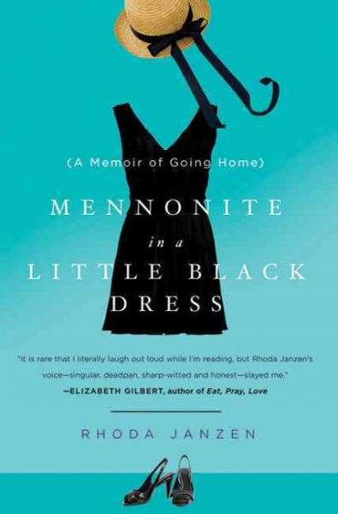

Welcome BACK, Hannah! Hannah: Between the Assassinations by Aravind Adiga $15 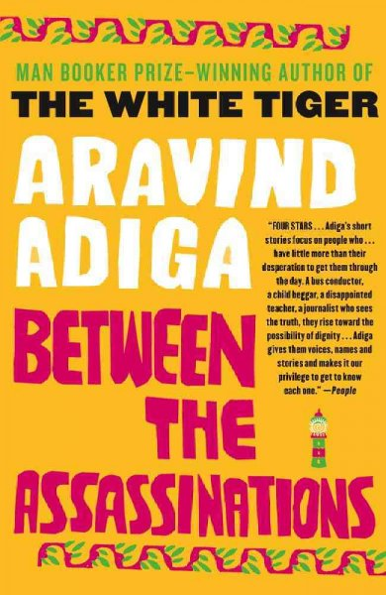 Little Bee by Chris Cleave $14 Hannah says: Fabulous! It was heartbreaking and hopeful at the same time. Very rare ☺
Jennie: Why My Third Husband Will be a Dog by Lisa Scottoline $21.99 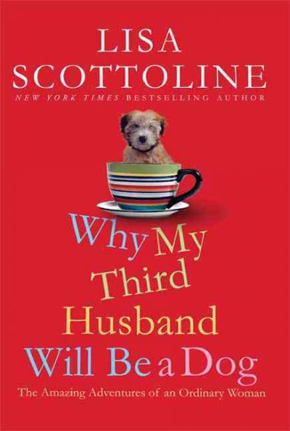 Jennie says: Very funny, her writing is very hilarious!
Jennifer:
Dog On It by Spencer Quinn on audio (paperback is $15)
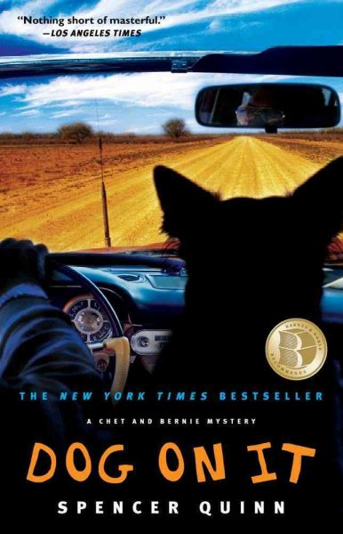 Jennifer says: I’m reading this mystery (the first in a series) based on a couple of
customers who emphatically informed me reading these is a must!

Dorset Festival of Authors & Artists is June 25th 12-8.

Gail:
Irreplaceable by Stephen Lovely $14.99 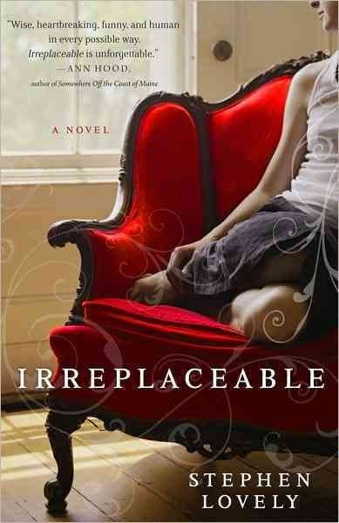 Gail says: This is an interesting story of both the recipient of a heart transplant and the husband of the woman whose heart goes to the recipient.
Knit Two by Kate Jacobs $15
Flying Changes by Sara Gruen $13.95
Dance of the Dissident Daughter by Sue Monk Kidd $13.95
Wolf at Twilight by Kent Nerburn
Cutting for Stone by Abraham Verghese $15.95
Beardance by Will Hobbs $5.99 Gail says: A great book for young boys and "old ladies" too!

Linda:
The Last Time I Saw You by Elizabeth Berg $25 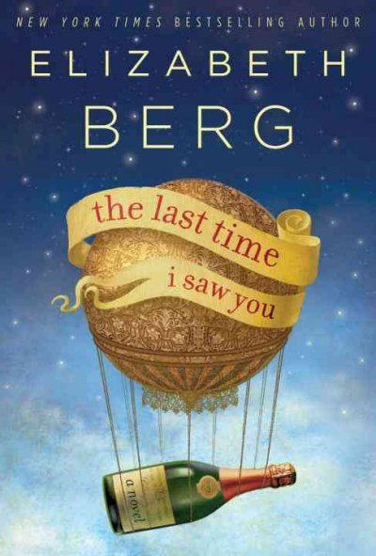 Linda says: As Dorothy, Pete, Mary Alice, Candy, and Lester consider returning to Clear Springs for their 40th high school reunion, all of the anxiety, quest for retribution, joy at seeing old friends, the recounting of conquests on and off the athletic fields/floors and all of those other emotions buried in their psyches come bounding out. Berg fans or anyone who has ever attended a class reunion will find much to like in Berg's newest novel.
Saving CeeCee Honeycutt by Beth Hoffman $25.95
Benny & Shrimp by Katarina Mazetti $14 Linda says: This book was first released in Sweden, and released in the U.S. last year. It's the charming

story of Benny, a 35-year-old dairy farmer, and Desiree, a refined and widowed 35-year-old librarian. They meet in the cemetery, where Benny is visiting his parents' graves and Desiree (later named Shrimp by Benny) is visiting the grave of her husband. The two characters
alternate chapters in telling the story, a device which I think worked wonderfully in unfolding their love story and the difficulties they experience in trying to blend their so very different lives. I'll be recommending this book to everyone I know as I think it's one of those books you'll remember for a long time after you've finished it.
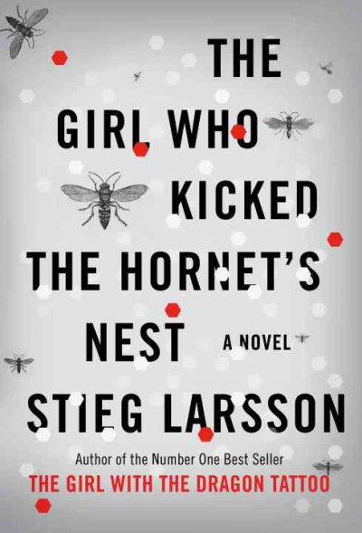
Linda says: And if you haven't begun the Stieg Larsson Millenium series mysteries:
The Girl with the Dragon Tattoo, The Girl Who Played with Fire and the just released The Girl Who Kicked the Hornet's Nest, I cannot recommend these three books highly enough. All three have already been made into movies in Sweden, and they are being made into movies in the United States soon. Be forewarned that they're not for the faint of heart, but I challenge you to quit before you've read all three--they're that good.

Sally: Agaat by Marlene Van Niekerk $19.95
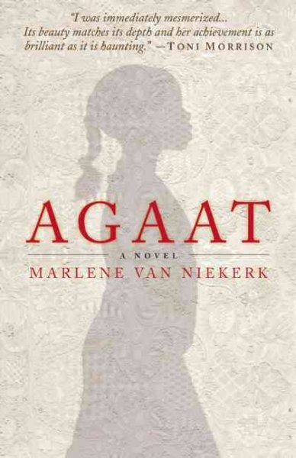 Sally says: Set in apartheid South Africa, Agaat explores the relationship between Milla, a 67-year-old white woman in the final

stages of ALS, and her black servant turned caretaker, Agaat. Milla's family has fallen apart, her country is on the brink of huge change, and all she has left are memories and her proud, contrary, yet affectionate guardian. The book is beautifully written!
Noah's Compass by Anne Tyler on audio $35 (hardcover is $25.95)
Dorset Festival of Authors & Artists is June 25th 12-8.

Cindie:
Growing Up Psychic by Lowell K. Smith
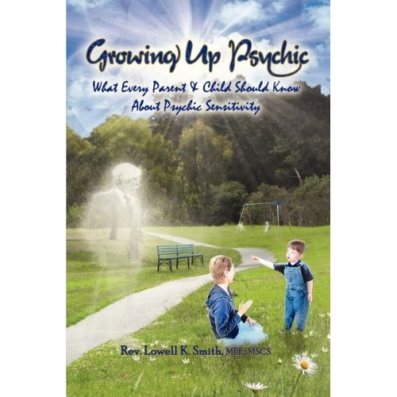
Cindie says: I met Lowell at hypnotherapy training in Virginia Beach, Va. He is one of the most extraordinary people I've ever encountered. Lowell's memoir is not only very interesting, but extremely helpful for anyone who has children, or works with children with special intuitive gift, the Indigo, Crystal and Starseed children. I am actually pretty skeptical of those who claim to
have the psychic abilities that Lowell claims to
have in his book, but after meeting him and learning from him, he is the real deal.

Dorset Festival of Authors & Artists is June 25th 12-8.

Youth Yak
New Douglas Wood picture books! For fans of Old Turtle, the author has released two new picture books!:

Where the Sunrise Begins $16.99
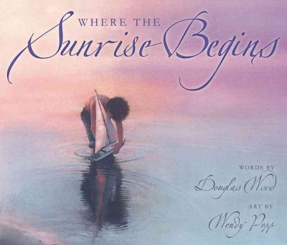 Radiant pastel artwork and simple, stirring poetry celebrate nature, from the great oceans that “enfold and encircle all the earth” to a single exquisite butterfly. The poetic lines raise questions about where the sunrise begins, drawing in global geography and cultural history: does the sun rise in Africa, “where life first arose and later walked on two legs”? The Middle East, “where the light of many great religions first shone”? In the Far East? We won’t spoil it for you, you’ll have to read it for yourself to find out.

Aunt Mary’s Rose $16.99
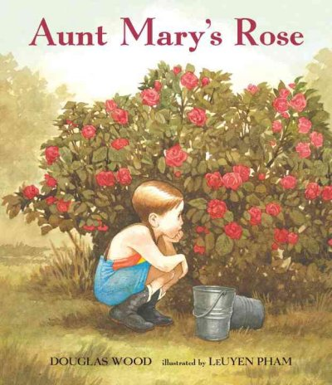 Aunt Mary has a very special rosebush in her garden. She says a little bit of Douglas can be found inside it. And she tells him how the rosebush has a little bit of Douglas’s daddy in it as well. And a little bit of his daddy’s daddy. And, of course, a little bit of Aunt Mary. Douglas Wood’s tender memoir is complemented by LeUyen Pham’s charming and engaging illustrations. Together they show how caring for a treasured rosebush provides a connection between generations, and an enduring expression of attentiveness and familial love.

Book Group Picks

Sister Wolf Book – Womens Wednesday Morning
June 9th @ 9AM:
The Turtle Catcher by Nicole Helget $13.95
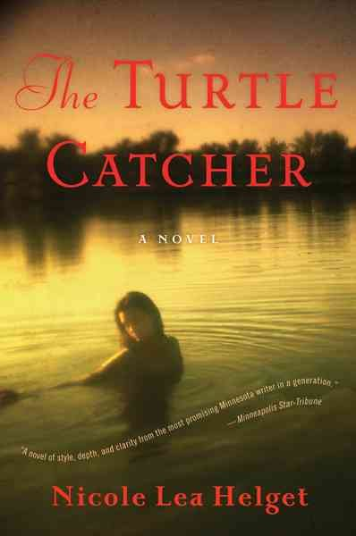

*The schedule has yet to be set. Check http://www.sisterwolfbooks.com/book-grp.html for updates or call Sister Wolf: 732-7565.

Sister Wolf Book – Womens Thursday Evening
June 3rd @ 7PM:
Irreplaceable by Stephen Lovely $14.99

June 17th at 7PM:
Wolf at Twilight: An Indian Elder's Journey Through a Land of Ghosts and Shadows bv Kent Nerburn $14.95 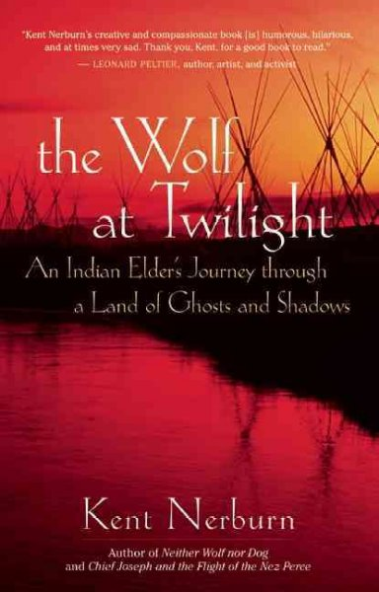
Dorset Festival of Authors & Artists is June 25th 12-8.

Faith Talk
Wednesday, June 16th @ 7PM
Einstein's God by Krista Tippett $16
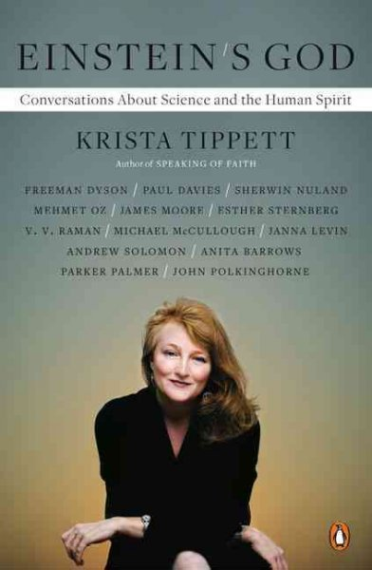

Poetry
Friday, June 4th @ 9AM
Flying : Prose/Poems by Beverly Rollwagen $14
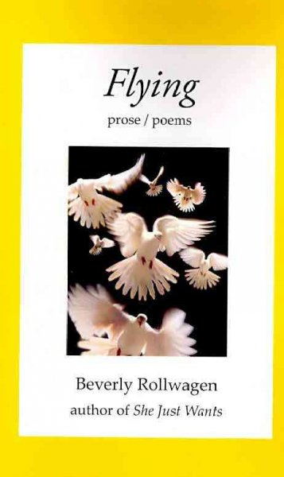

Beagle Books Mens Book Group
Tuesday, June 16th at 8AM (note: this meeting will be held at the home of a book group member. Call Beagle Books for directions):

The Girl with the Dragon Tattoo by Stieg Larsson $7.99/$14.95 (two sizes of paperback available)

Dorset Festival of Authors & Artists is June 25th 12-8.

Park Rapids Friends of the Library Book Group
Friday, June 18th at 10:30AM at the library:
Radio Nights and Air Raid Days: Hanging on for Dear Life by Don Schroeder $14.99


Blue Stocking Society Book Club (closed group)
June 9th
Compromising Positions by Susan Isaacs $14 

Dorset Festival of Authors & Artists is June 25th 12-8.

Dorset Festival of Authors & Artists is June 25th 12-8.

Dorset Festival of Authors & Artists is June 25th 12-8.

