Changes by Sally
Sister Wolf Books will be closing for the season on September 20. Many thanks to each of you for making the summer memorable. As always, the book groups were the heart of the store. My staff and I have enjoyed engaging both in book talk and more personal conversation with you. We'll keep in touch over the off season through this newsletter, and we also look forward to your e-mails and calls.
I'd like you to know about some changes in my life this summer, and the ways they will--and will not--affect the stores. My husband recently accepted a faculty position at the University of North Dakota in Grand Forks, and he is living there now. Our home in the Twin Cities is on the market and I'll join Bob in Grand Forks after Sister Wolf closes. We will continue to own and operate both Sister Wolf Books and Beagle Books. The stores have new e-mail addresses: sisterwolfbooks@arvig.net and beagle-books@arvig.net. The comcast accounts are still live, but will be discontinued later this fall. I don't anticipate that anything else will change. Please wish me well as we begin to downsize!
Sales Beagle Books Labor Day Sale: All Melissa & Doug plush are 40% off! Also, all sale books are at least 50% off. Sale runs Saturday, September 5th through Monday, September 7th.
Sister Wolf Books End-of-Season Sale: Our sale begins Saturday, Sept. 5, and extends through the end of the season. Many non-book items are on sale for 30-70% reductions in price. This includes select cards, jewelry, puzzles, and children's toys as well as many other items. There will be great bargains!

Signings at Sister Wolf on September 6
From noon to 2, two Minnesota authors will be meeting the public and signing books at Sister Wolf. Dennis Leger is the author of Milk Market, a mystery set in Minnesota. Jim Olson wrote Boomer, a novel about coming of age as a member of the baby boom generation.
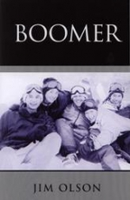
Midwest Connections Picks

We missed an August pick last month! So here it is:
Fifth Floor by Michael Harvey $14.95

Private detective Michael Kelly returns in a lightning-paced, intricately woven mystery. When Kelly is hired by an old girlfriend to tail her abusive husband, he expects trouble of a domestic rather than a historical nature. Life, however, is not so simple.
The trail leads to a dead body in an abandoned

house on Chicago’s North Side and then to places Kelly would rather not go: specifically, City Hall’s fabled fifth floor, where the mayor is feeling the heat. Kelly becomes embroiled in a scam that stretches from current politics back to the night Chicago burned to the ground. Along the way, he finds himself framed for murder, before finally facing a killer bent on rewriting history.
September Picks:
Seasons on Henry's Farm: A Year of Food and Life on an Organic Farm by Terra Brockman $25
For fans of Animal, Vegetable, Miracle, Michael Pollan’s books, and Deborah Madison’s eating local cookbooks, this is a must-read!

From Henry’s Farm website http://www.henrysfarm.com/ :The Seasons on Henry’s Farm tells the story of our family and our life on the farm in the form of a year-long memoir–with recipes–that takes readers through each of 52 seasons of life on the farm.

 Newsletter Coupon 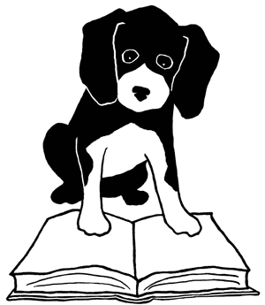
20% off any one book.

Our Boys: A Perfect Season on the Plains with the Smith Center Redmen by Joe Drape $25
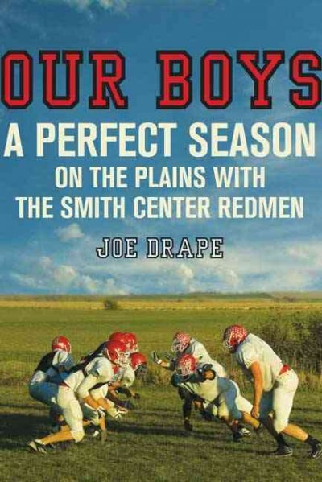
In the fall of 2008, the football team in Smith Center, Kansas – population: 1,931 – embarked on a quest for its fifth undefeated season, its fifth state championship, and a new state record for consecutive victories. But to do so, the Redmen faced a potentially destabilizing transition: the greatest senior class in school history had graduated, and their longtime coach, Roger Barta, was contemplating retirement.
Lights on a Ground of Darkness: An Evocation of a Place and Time by Ted Kooser $10.95
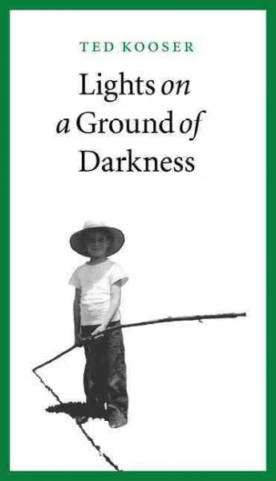
Like the yellow, pink, and blue irises that had been transplanted from house to house over the years, the stories of poet Ted Kooser’s family had been handed down until, as his mother lay ill and dying, he felt an urgency to write them down. With a poet’s eye for detail, Kooser captures the beauty of the landscape and the vibrancy of his mother’s Iowa family, the Mosers, in precise, evocative language.

The center of the family’s love is Kooser’s uncle,

Elvy, a victim of cerebral palsy. Elvy’s joys are fishing, playing pinochle, and drinking soda from the ice chest at his father’s roadside Standard Oil station. Kooser’s grandparents, their kin, and the activities and pleasures of this extended family spin out and around the armature of Elvy’s blessed life.

Kooser has said that writing this book was the most important work he has ever undertaken because it was his attempt to keep these beloved people alive against the relentless erosion of time.
Twisted Tree by Kent Meyers $24
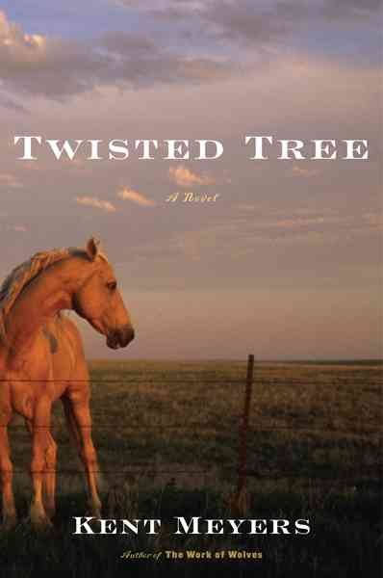
Hayley Jo Zimmerman is gone. Taken. And the people of small-town Twisted Tree must come to terms with this terrible event—their loss, their place in it, and the secrets they all carry.

In this brilliantly written novel, one girl’s story unfolds through the stories of those who knew her. Among them, a supermarket clerk recalls an encounter with a disturbingly thin Hayley Jo. An ex-priest remembers baptizing Hayley Jo and seeing her with her best friend, Laura, whose mother the priest once loved. And Laura berates herself for all the running they did, how it fed her friend’s addiction, and how there were so many secrets she didn’t see. And so, Hayley Jo’s absence recasts the lives of others and connects them, her death rooting itself into the community in astonishingly violent and tender ways.

Staff Picks We have a new staff member! Her name is Jennie (not to be confused with Jennifer). She has a lot of energy and we’re so glad to have her on board!
Bob: Introduction to Chemical Engineering Thermo Dynamics (textbook for a class Bob is teaching at the University of North Dakota, Grand Forks). 
Linda:
Never Trust a Thin Cook and Other Lessons from Italy's Culinary Capital by Eric Dregni $22.95 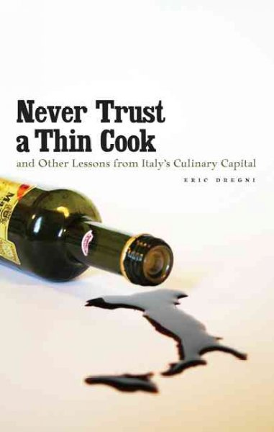
The Horse Boy: A Father's Quest to Heal His Son by Rupert Isaacson $24.99
Linda says: An astounding real-life story of the quest for Rupert and his wife, Kristin, to find healing for their severely autistic son, Rowan. Rupert, a lifelong horseman, one day discovered the unusual connection then four-year-old Rowan had with a testy mare owned by a neighbor. After obtaining permission from the neighbor for Rowan to ride said mare, Betsy, Rowan began to have speech and behavior breakthroughs thought impossible by his parents and medical team. Frustrated with western medicine's inability to provide answers, Rupert convinces his wife to take Rowan to Outer Mongolia, where he is immersed in two months of riding Mongolian

horses across the lands with his father and to meet and be exposed to the traditional shaman healers. This is a story that will linger in my mind for a long time to come.
Lavender Mornings by Jude Devereaux on audio $29.99 Linda says: Hey, everybody is entitled to a little 'fluff' once in a while, and this fit the bill nicely.
South of Broad by Pat Conroy $29.95 Linda says: I’m loving every descriptive word of it!
Jody: Alcoholism & Addiction Cure: A Holistic Approach to Total Recovery by Chris Prentiss $15.95
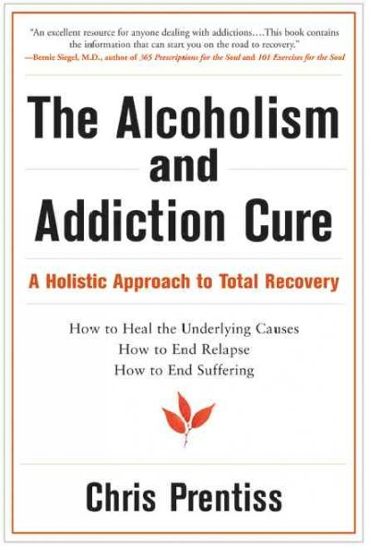
Jody says: This book gives people a new paradigm for dealing with addiction. It enables them to recognize the root causes of addiction, heal them, rise above them, and be free.

Cindie:
A People's Tragedy: The Russian Revoluion 1891-1924 by Orlando Figes $25 (in paperback!)

Cindie says: I'm on page 145. There are 824 pages....Maybe I should have stuck to trying to read War and Peace this summer.
(This is research for Cindie’s novel – for a more enjoyable recent read by Cindie, see Youth Yak)

Sally:
That Old Cape Magic by Richard Russo on audio $40
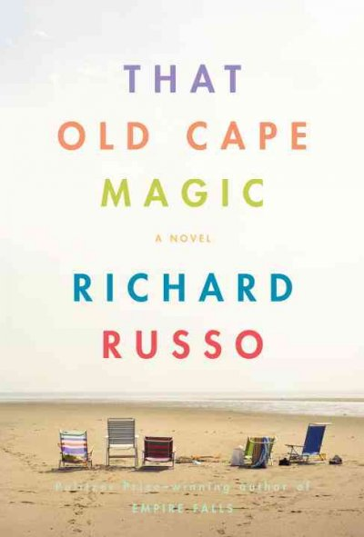
Sally says: I like Russo's work, and enjoyed this book a great deal. Russo explores the relationship of the dynamics of a long-term marriage which is floundering, and the ways in which the main characters' families of origin shaped them and influence their marriage. The characters, even the minor ones, are carefully and believably crafted, and the ordinary events of their lives are both credible and interesting. There's also a great deal of humor in this book. The events of the wedding rehearsal evening made me laugh out loud! That Old Cape Magic is available at Beagle Books in hardcover for $25.95.
Dewey by Vicki Myron on audio
The Boy in Striped Pajamas by John Boyne on audio

Gail:
The Heart of Christianity: Rediscovering a Life of Faith by Marcus Borg $14.95
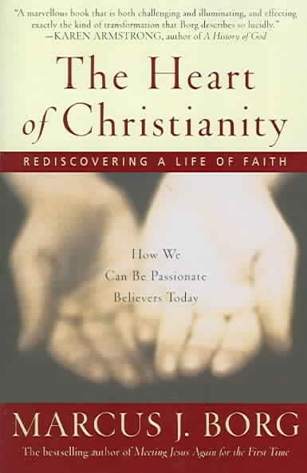
Secret History of Lake Amikota by Jody Russell The Bracelet by Betsy Johnson-Miller. Gail says: These are young adult books as different as night and day -- both good. The authors are from Minnesota.
Windows of Brimness by Bill Holm. Gail says: This has been one of my favorite reads of the summer. Bill Holm died in February. He will be missed as a wonderful Minnesota writer.

Jennifer:
Blue Zones: Lessons for Living Longer from the People Who've Lived the Longest by Dan Buettner $14.95

Jennifer says: This is a book I might not have picked up on my own, but I kept hearing customers talk about it. I’ve been reading a blue zone per night (there’s four) and it’s fascinating. I’ve only been reading about one zone per night so that I can take the time to really mull over the lessons that each zone has to offer. My favorite bits of advice so far include eat dark chocolate, drink red wine, eat nuts, walk, drink water, and spend FUN time with friends.
Heart-Shaped Box by Joe Hill on audio $39.95

Youth Yak
Moose on the Loose by Kathy-jo Wargin
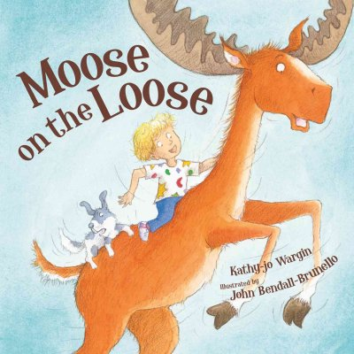
What would you do with a moose on the loose? Would you chase him, or race him, or stand up to face him? What would you do with a moose on the loose? What would you do with a moose in your yard? Or in your house? How about in your room? Or in your tub? Would you give him two boats? Would you see if he floats? What would you do?

Colorful, comic artwork highlights the hilarity that ensues when wildlife wanders indoors. Can boy best beast? By story's end, young readers will know exactly what to do when a moose goes on the loose!
Pick from Cindie:
Daughters of the Sea: Hannah by Kathryn Lasky $16.99 
Cindie says: An enticing fairytale about a mermaid. This would be great for 9-12 year olds.

Book Group Picks
Sister Wolf Books:
Wednesday Morning Womens Group:
September 9th at 9AM – The Guernsey Literary and Potato Peel Pie Society by Mary Ann Shaffer and Annie Barrows $14

Joint Pot Luck:
September 16th - The Art of Racing in the Rain by Garth Stein $14.99
Call Sister Wolf Books 732-7565 for details.
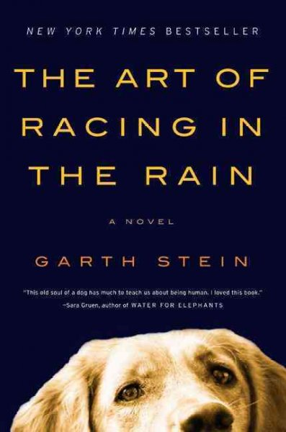
Beagle Books:
The Womens Book group will be re-forming in September! Due to requests, we have changed our meeting time to the 3rd Saturday of the month at 10AM.

Beagle Womens Book Group:
Saturday, September 19th at 10AM at Beagle Books-
Rooftops of Tehran by Mahbod Seraji $15


Beagle Mens Book Group:
Tuesday, September 15th at 8AM at Beagle Books-
Rhino Ranch by Larry McMurtry $26


