Out for Blood
by Jen
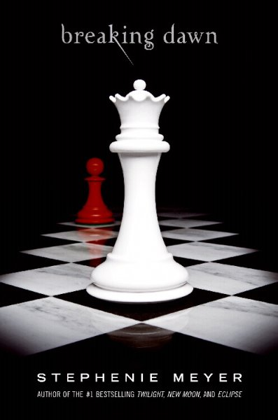

If you have a teenage girl reader in your vicinity, then you’ve likely heard about Stephenie Meyer’s Twilight series: a clean, teen, vampire series. It’s not just teens reading these though, we’ve heard reports of moms and daughters fighting over the books! (In the name of peace, get your own). We’ve even heard rumor from a reliable source that teen boys are reading this series as a way to talk with their female peers. The last installment of the Twilight series, Breaking Dawn, will be released for sale on August 2nd. So of course, we’re going to have a party, starting at 11PM at Beagle Books on FRIDAY, AUGUST 1ST. At midnight, when it’s officially Aug. 2nd, the book will go on sale. While we wait for midnight, we’ll be hosting a costume contest – the theme is weddings. (Yes, the wedding theme is related to the book). The best costume will earn a free copy of Breaking Dawn. The winner will be announced at 11:59. We’ll also be eating wedding cake. Additionally, we’re offering a 10% discount on Breaking Dawn to anyone who signs up to donate blood in the Aug. 19-21 Park Rapids blood drive. You have to be 17 years old to donate blood, so for those under 17, you’ll literally have to ask family members for blood.

Stone Soup FEAST!
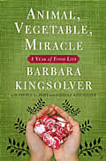
The date for the Stone Soup feast has been set: Sunday, August 24th, 5PM at Heartland Park in Park Rapids. Everyone is welcome, including children and peculiar relatives who talk too much. You need not have participated in any of the Stone Soup meetings to join in the feast. The only requirement is that you bring local food (and if you absolutely can’t think of any food to bring, then bring Forestedge wine).

Midwest Connections Picks

August Picks:
Red Sky in Morning by Patrick Culhane
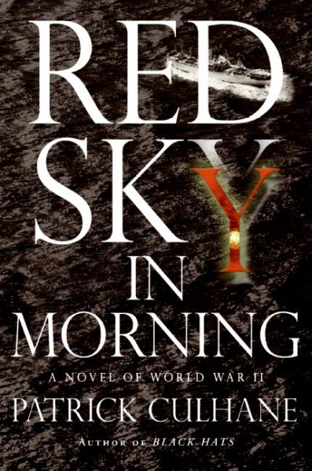
Iowa native Ensign Peter Maxwell longs for action after two years of leading the Navy choir after being called up from the reserves following Pearl
Harbor. He gets a new posting on the USS Liberty Hill, stationed at San Francisco’s Port Chicago, but his new captain has no respect for junior officers like Peter and even less for the African-Americans who make up his crew. Despite tensions between captain and crew, a two-week

shakedown cruise goes well. When the ship returns to San Francisco, however, Port Chicago is blown up and Liberty’s second in command is murdered. There is an enemy within, and Maxwell will do everything to stop him, including putting himself on the front line of danger.

The Man in the Blizzard by Bart Schneider

This tongue-in-cheek little crime novel takes place shortly before the Republican National Convention comes to St. Paul. Twin Cities pothead private eye Augie Boyer is out of sorts. He’s been smoking too much Ponchartrain Pootie, expanding his waistline with too much fried food, thinking too much about his ex-wife, suffering from a dismal testosterone level, and grousing about the current Republican governor’s vetoes and blatant right-wing favoritism. When Augie discovers a plot to kill three abortion doctors in connection with a Neo-Nazi-funded “Labor Day” anti-abortion rally on the state capitol grounds, he rallies his troops – a St. Paul detective who’s a rabid poetry evangelist; a suave black-Irish code master, and Blossom, his spike-haired ex-con assistant. The plot thickens by the minute, Augie’s radical songwriter/singer daughter arrives for a counter-rally, and danger comes ever closer……

 Newsletter Coupon 
20% off any one book.

Stalking Susan by Julie Kramer 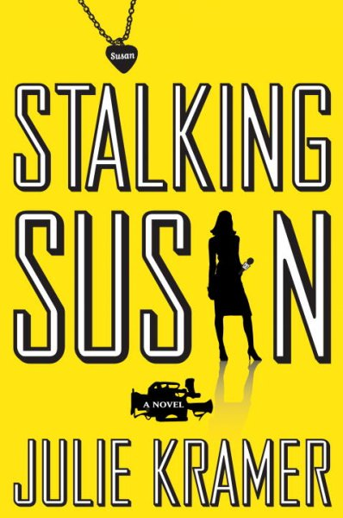 Television reporter Riley Spartz is recovering from a heartbreaking, headline-making catastrophe of her own when a longtime police source drops two homicide files in her lap in the back of a dark movie theater. Both cold cases involve women named Susan strangled on the same day, one year apart. Last seen alive in one of Minneapolis’s poorest neighborhoods, their bodies are each dumped in one of the city’s wealthiest areas. Riley senses a pattern between those murders and others pulled from a computer database of old death records. She must broadcast a warning soon, especially to viewers named Susan, because the deadly anniversary is approaching.

Staff Reads
Bob-
Neitherworld Book One Akiiwan by Scott Baker
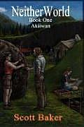
Brian- Lord of the Flies by William Golding
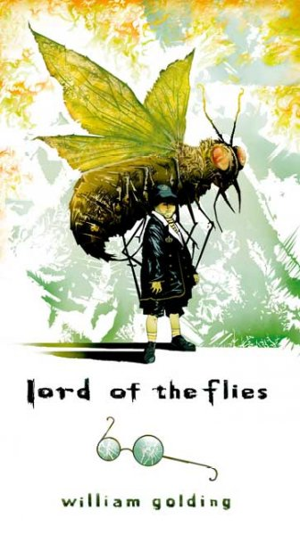

Gail-
The Friday Night Knitting Club by Kate Jacobs
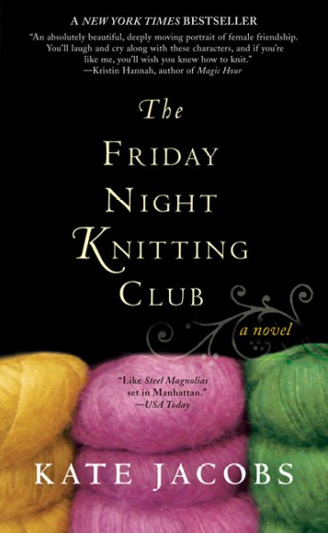
Reluctant Tuscan by Phil Doran
Gail says: This is a fun, light summer read about
restoring an old home in Tuscany.
Hannah- Freddy and Fredericka by Mark Helprin 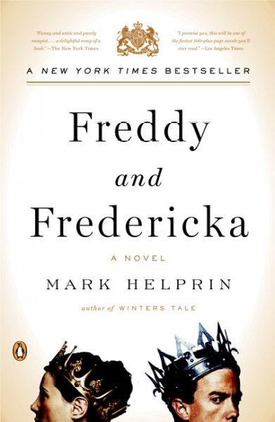 Note: Hannah’s enthusiasm for this book is absolutely infectious!
The Glimmer Palace by Beatrice Colin
Severance by Robert Olen Butler
Atonement by Ian McEwan
Jennifer- The Artist’s Way: A Spiritual Path to Higher Creativity by Julia Cameron 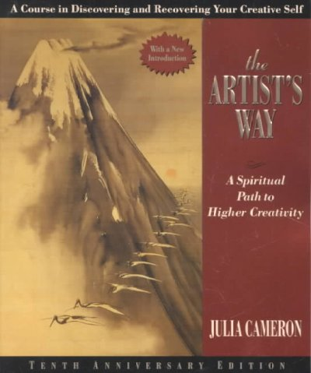
Animal, Vegetable, Miracle by Barbara Kingsolver, Stephen Hopp, and Camille Kingsolver Rebel Angels by Libba Bray on audio

Sally- Shelter Half by Carol Bly 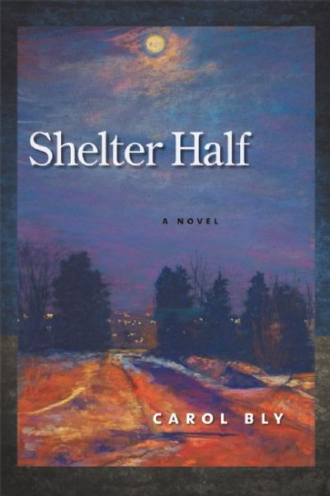 The Brief Wondrous Life of Oscar Wao by Junot Diaz on audio
Linda- The Lace Reader by Brunonia Barry
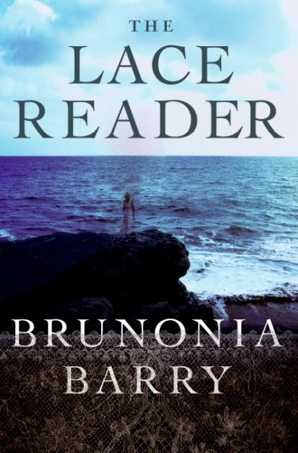
Linda says: Towner Whitney, former resident of Salem, MA, returns to her childhood home when her beloved Aunt Eva disappears. All of the Whitney women can read the future in a piece of lace, all except Towner, who refuses to use her talent after the death of her twin sister, Lyndley. Mysterious and rich in historical detail, The Lace Reader will have you ignoring housework and yard work and losing sleep as you immerse yourself in one of the best books about women I've read in quite some time. Truck by Michael Perry
The Rest of Her Life by Laura Moriarty
Cindie- Peony in Love by Lisa See 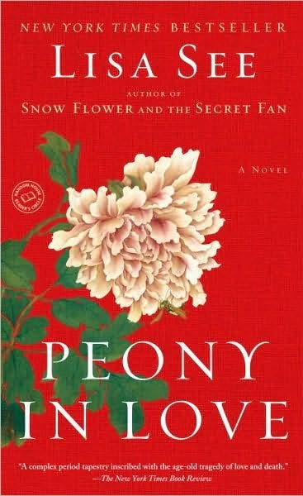

Rhoda-
A Mango-Shaped Space by Wendy Mass

Rhoda says: I love this young adult novel! The story revolves around a teen girl with synesthesia, a condition which causes her to see letters and numbers in colors. In addition to coming to terms with her unique view of the world, she is also dealing with the recent death of her beloved grandfather. I highly recommend this nice little read!




Youth Yak
Many of you have been in search of “good stuff to have at the cabin”. Here are a few recommendations:

From Cindie-
Carl's Summer Vacation by Alexandra Day and other Good Dog Carl books by the same author.

These are perfect for kids going to the lake cabin or grandparents to keep in the kids' books, toys and games stash!

From Jen-
I Spy with My Little Eye: Minnesota by Kathy-jo Wargin
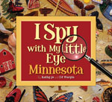

Agate: What Good is a Moose? by Joy Morgan Dey
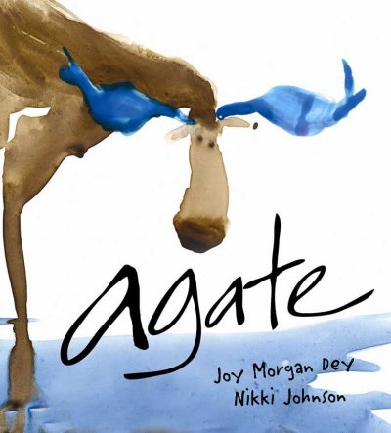

Also, for rainy days, Sister Wolf has lots of great puzzles (including some that we GUARANTEE you will never lose a piece) and games for all ages.

Beagle Books Book Group Reminders
Beagle Books Men’s Group meets the 3rd Tuesday of the month at 8AM. On August 19th, they’ll discuss Iron John: a Book about Men by Robert Bly.
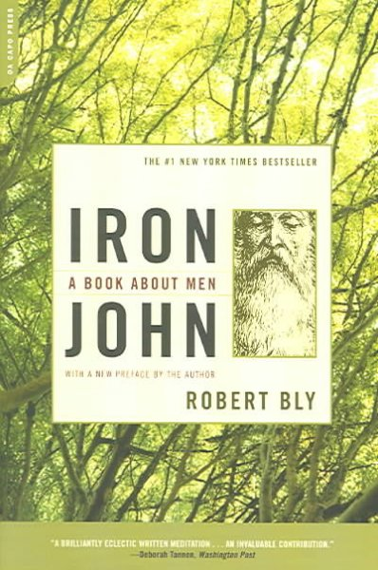

The Beagle Books Women’s Group will re-convene in September. Please call 237-2665 or email beagle-books@comcast.net if you’d like to be included in the email group, if you have suggestions for books, or if you’d like to propose a date/time for the group.

Sister Wolf Books Book Group Reminders
The Women’s Wednesday morning group meets every other Wednesday at 9:00. On August 13th, they’ll discuss What is the What by Dave Eggers
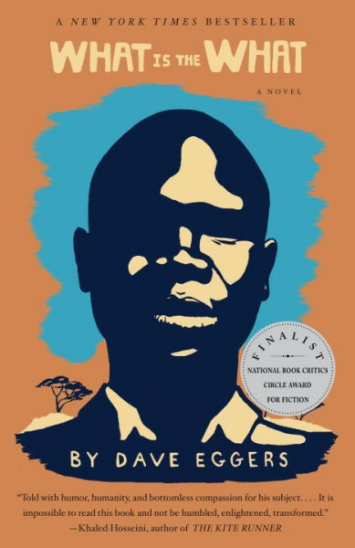

On August 27th, they’ll discuss Loving Frank by Nancy Horan
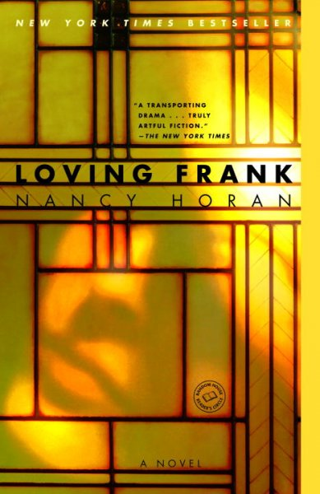

The Women’s Thursday evening group meets every other Thursday at 7PM. On August 7th, they’ll discuss The Rest of Her Life by Laura Moriarity
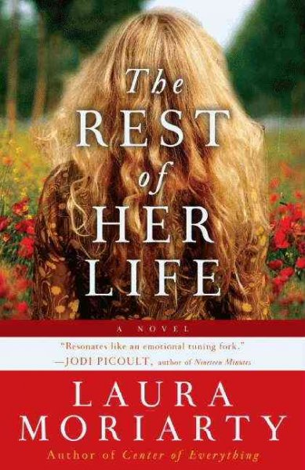

On August 21st, they’ll discuss Shelter Half by Carol Bly

The Poetry Group will meet in August on Tuesday, August 12th at 10AM. The discussion will be led by the local Twigs group.

The Faith Talk Group will meet in August on Tuesday, August 12th at 7PM. The group is led by Pastor Gary Walpole. Suggested readings include: The Great Awakening by Jim Wallis, Souled Out by E.J. Dionne Jr., and God and Empire by John Dominic Crossan. It’s not necessary to buy or read these books to participate in the group.

